VISVESVARAYA TECHNOLOGICAL UNIVERSITY



Breast Cancer Tumor Detection and Treatment Recommendation System

# PROJECT REPORT

*Submitted By*

|  |  |
| --- | --- |
| **ANURAG PATIL** | **1RF20IS010** |
| **SHASHANK S RAO** | **1RF20IS049** |
| **PRARTHANA N AITHAL** | **1RF20IS039** |
| **RAHUL HARISH** | **1RF20IS042** |

# Under the Guidance of Prof.Samantha RS

# Assistant Professor

**Information Science and Engineering, RVITM**

***in partial fulfillment for the award of the degree of***

***Bachelor of Engineering***

***In***

**Information Science and Engineering**



RV INSTITUTE OF TECHNOLOGY AND MANAGEMENT BANGALORE 560076

2023-2024



# CERTIFICATE

Certified that the project work titled **‘Breast Cancer Tumor Detection and Treatment Recommendation System ’** is carried out by **Anurag Patil (1RF20IS010), Shashank S Rao(1RF20IS049), Prarthana N Aithal (1RF20IS039), Rahul Harish(1RF20IS042),** who are bonafide students of RV Institute of Technology and Management, Bangalore, in partial fulfillment for the award of degree of **Bachelor of Engineering** in **Information Science and Engineering** of the Visvesvaraya Technological University, Belgaum during the year **2023-2024**. It is certified that all corrections/suggestions indicated for the internal Assessment have been incorporated in the report deposited in the departmental library. The project report has been approved as it satisfies the academic requirements in respect of project work prescribed by the institution for the said degree.

### Signature of Guide: Signature of Head of the Department: Signature of Principal:

**External Viva**

### Name of Examiners Signature with date

**1**

**2**

# DECLARATION

We, **Anurag Patil, Shashank S Rao, Prarthana N Aithal, Rahul Harish** the students of Seventh Semester B.E, Department of **Information Science and Engineering**, hereby declare that the Project titled “**Breast Cancer Tumor Detection and Treatment Recommendation System”** has been carried out by us and submitted in partial fulfillment for the award of degree of Bachelor of Engineering in **Information Science and Engineering.** We do declare that this work is not carried out by any other students for the award of degree in any other branch.

### Place: Bangalore Date: 29/05/2024

|  |
| --- |
| **1. ANURAG PATIL** |
| **2. SHASHANK S RAO** |
| **3. PRARTHANA N AITHAL** |
| **4. RAHUL HARISH** |

**Names Signature**

# ACKNOWLEDGEMENT

The satisfaction and the successful completion of **Final Year Project** would be incomplete without the mention of the people who made it possible constant guidance of these persons and encouragement crowned our efforts with success and glory.

We would like to thank our guide **Prof. Samatha R Swamy, Assistant Professor**, Department of ISE, R V Institute of Technology and Management, Bengaluru, for his constant guidance, input, and encouragement.

We thank **Dr Latha C A, Head Of The Department**, Department of Information Science and Engineering, R V Institute of Technology and Management, Bengaluru, for the encouragement.

We would like to extend gratitude to **Dr Nagashettappa Biradar, Principal**, R V Institute of Technology and Management, Bengaluru, for facilitating us to build and present the project.

We would like to extend our gratitude to the **Management**, **RV Institute of Technology and Management**, Bengaluru, for providing all the facilities to create this project.

We would like to thank all the **Faculty** and **Technical Staff** of the college for their co- operation.

Finally, we extend our heartfelt gratitude to our **families** for their encouragement and support without which we would not have come so far. Moreover, we thank all our **friends** for their invaluable support and cooperation.

# ABSTRACT

Breast cancer is one of the leading causes of cancer-related mortality among women worldwide, emphasizing the importance of early detection and accurate treatment planning. This project introduces a comprehensive **Breast Cancer Tumor Detection and Treatment Recommendation System**, designed to automate and optimize the diagnostic and therapeutic processes. Using advanced deep learning and machine learning models, the system can detect and segment tumors from breast imaging data, characterize them using the BI-RADS framework, predict cancer stages, and recommend suitable treatments based on clinical guidelines. By integrating multiple data sources and leveraging AI-driven insights, the system aims to support healthcare professionals in delivering precise and personalized care.

The architecture comprises distinct yet interconnected modules: tumor detection, characterization, stage prediction, and treatment recommendation. A UNet-based deep learning model is employed for tumor segmentation from DICOM images, ensuring high accuracy and reliability in identifying tumor regions. Tumor characteristics such as size, shape, and margins are analyzed to assign BI-RADS categories, reflecting the likelihood of malignancy. Machine learning models then use these findings alongside patient metadata to predict cancer stages. Finally, the treatment recommendation module generates personalized therapeutic strategies, including surgery, chemotherapy, radiation therapy, or observation, aligned with the predicted stage and patient-specific factors.

This system leverages state-of-the-art tools, such as PyTorch and Scikit-learn, to ensure robustness and scalability, with evaluation metrics like Dice coefficient and precision-recall ensuring quality assurance. Despite challenges like limited labeled data and variability in imaging quality, solutions such as data augmentation, transfer learning, and preprocessing pipelines were implemented to enhance performance. Future iterations aim to integrate explainable AI for better interpretability and multi-modal data inputs for comprehensive decision-making. This innovative project demonstrates the potential of artificial intelligence in revolutionizing cancer diagnostics and treatment planning, fostering improved outcomes for patients worldwide.

# TABLE OF CONTENTS

### Abstract i

**List of Figures v**

List of Tables vi

1. Introduction 1
   1. Problem Statement 2
   2. Scope and Motivation 2
   3. Objective 3
   4. Methodology 4
   5. Overview of the Report 6
2. Literature Survey 8
   1. System Study 9
   2. Proposed Work 9
      1. Existing System 10
      2. Proposed system 11
3. Theory & Fundamentals of Area related to Problem Statement 13
   1. System Requirement Specification 13
   2. Hardware Requirement 13
   3. Software Requirement 14
   4. Functional Requirement 15
   5. Non-Functional Requirement 16
4. Design 18
   1. Design Overview 18
   2. System Architecture 18
   3. Modules 20
      1. Backbone and Neck 20
      2. Multiscale Analysis 20
      3. Data Exploration 20
      4. Data Augmentation 21
      5. Interaction Module 21
      6. Prediction and Interface 21
   4. Design Diagrams 22
      1. Use Case Diagrams 22
      2. Class Diagram 23
      3. Activity Diagram 24
      4. Sequence Diagram 25
      5. Collaboration Diagram 25
      6. Component diagram 26
      7. Deployment Diagram 27
5. Implementations 29
   1. Data Importing 29
   2. Pre-processing of data 29
      1. Data Cleaning 30
      2. Data Partitioning 30
      3. Handling Imbalanced Data 30
      4. Image Resizing and Normalization 30
      5. Augmentation 30
   3. Validation 31
   4. Modelling 31
   5. Swin transform and Sigmoid function 32
   6. Libraries and Flask App 32
      1. Integrating Sigmoid Activation Function 33
      2. Integrating Swin Transform Function 33
      3. Adding to Web page 33
   7. Security Features 34
   8. Main Function 34
6. Result, Discussions and Inferences 36
7. Conclusion and Future Scope 49

References 51

|  |  |  |
| --- | --- | --- |
| **Fig No.** | **Figure Name** | **Page No.** |
| Fig 4.1 | System Architecture | 19 |
| Fig 4.2 | Use Case Diagram | 22 |
| Fig 4.3 | Class Diagram | 23 |
| Fig 4.4 | Activity Diagram | 24 |
| Fig 4.5 | Sequence Diagram | 25 |
| Fig 4.6 | Collaboration Diagram | 26 |
| Fig 4.7 | Component Diagram | 27 |
| Fig 4.8 | Deployment Diagram | 28 |
| Fig 6.1 | Home Page | 36 |
| Fig 6.2 | Signup Page | 37 |
| Fig 6.3 | Validation Form | 38 |
| Fig 6.4 | Sign In Page | 39 |
| Fig 6.5 | Image Uploading Page | 40 |
| Fig 6.6 | Image Analyzing Page | 41 |
| Fig 6.7 | Object Detection | 42 |
| Fig 6.8 | Single-class average precision comparison | 43 |
| Fig 6.9 | PR Curve Comparison | 43 |
| Fig 6.10 | Confusion Matrix for MCS-YOLO | 44 |

|  |  |  |
| --- | --- | --- |
| **Table No.** | **Table Name** | **Page No.** |
| Table 6.1 | Performance comparison of YOLOv5s and MCS- YOLO | 46 |
| Table 6.2 | Experiment results comparing different algorithmic models | 47 |
| Table 6.3 | Experimental results of MCS algorithm | 48 |

# Chapter 1

**Introduction**

Breast cancer is a major public health concern and one of the leading causes of cancer-related deaths among women globally. Early detection of breast tumors and accurate assessment of their malignancy are critical for improving patient survival rates. Advances in medical imaging and artificial intelligence (AI) have opened new avenues for enhancing diagnostic accuracy and personalizing treatment strategies. However, the integration of these technologies into a cohesive, user-friendly system remains a significant challenge. This project addresses this need by developing a **Breast Cancer Tumor Detection and Treatment Recommendation System** that leverages state-of-the-art AI techniques to assist healthcare professionals in making timely and precise clinical decisions.

The system is designed to streamline the breast cancer care workflow, starting with tumor detection and segmentation from medical imaging data. Using a UNet-based deep learning architecture, the system identifies and highlights tumor regions from DICOM images, providing a robust foundation for further analysis. Tumor characterization is performed using the BI-RADS (Breast Imaging-Reporting and Data System) framework, which evaluates tumor attributes such as size, shape, margins, and density. These insights, combined with patient-specific data, enable the prediction of cancer stages, which is critical for determining the appropriate course of treatment. The recommendation module utilizes clinical guidelines and machine learning algorithms to suggest personalized treatment options, including surgery, chemotherapy, radiation therapy, or observation, tailored to the patient’s condition.

This comprehensive system addresses key challenges in breast cancer diagnosis and treatment, such as variability in imaging quality and the complexity of integrating diverse data sources. By automating critical tasks like tumor segmentation and stage prediction, the system reduces the cognitive load on clinicians and minimizes the risk of human error. Furthermore, its modular architecture allows for scalability and future enhancements, such as the incorporation of multi-modal data and explainable AI techniques. By integrating cutting-edge technology into the clinical workflow, this project aims to improve diagnostic precision, optimize treatment outcomes, and contribute to the broader adoption of AI in healthcare

## Problem Statement

Breast cancer is a leading cause of cancer-related deaths among women worldwide, with millions of new cases diagnosed each year. Early detection and precise treatment planning significantly improve patient outcomes, yet traditional diagnostic processes face several challenges. These include variability in imaging quality, subjective interpretation of tumor characteristics, and the time-intensive nature of manual analysis. Furthermore, treatment decisions often rely on generalized guidelines that may not fully account for individual patient profiles, leading to suboptimal outcomes.

Despite advancements in medical imaging and AI, existing solutions for breast cancer diagnosis and treatment are often fragmented, focusing on isolated tasks such as tumor detection or characterization without providing an integrated, end-to-end system. This fragmentation results in inefficiencies and limits the ability to make timely, data-driven decisions. The lack of personalized treatment recommendations further exacerbates the issue, as patients may receive therapies that are not tailored to their specific cancer stage or biological markers.

## Scope and Motivation

1. **Comprehensive Breast Cancer Management**: The system aims to provide an end-to-end solution for breast cancer care, from tumor detection to treatment recommendation. This integration addresses the fragmented nature of current diagnostic and therapeutic workflows, ensuring timely and accurate clinical decisions. The increasing global burden of breast cancer motivates the need for such a holistic approach to improve patient outcomes.
2. **Harnessing Advanced AI Technologies**: By employing deep learning for tumor segmentation and machine learning for stage prediction and treatment recommendations, the system ensures precision and reliability. This scope aligns with the motivation to leverage advancements in AI to overcome the limitations of traditional diagnostic methods prone to variability and human error.
3. **Personalized Patient Care**: The system is designed to provide tailored treatment recommendations based on tumor characteristics, cancer stage, and individual patient profiles. This scope is driven by the motivation to move away from generalized treatment protocols, which may not adequately address patient-specific needs, thereby improving therapeutic outcomes.
4. **Scalable and Accessible Solution**: The modular architecture ensures adaptability for future enhancements, such as integrating genetic and molecular data or incorporating explainable AI techniques. The motivation here is to make advanced breast cancer diagnostics accessible to resource-limited settings, reducing disparities in healthcare quality and availability.

## Objective

1. **Accurate and Automated Tumor Detection**: Design and develop a deep learning-based model, leveraging architectures like UNet, to detect and segment breast tumors from medical imaging modalities such as mammograms, ultrasounds, and MRIs. The model should deliver high accuracy, ensuring minimal false positives and negatives to reduce diagnostic errors.
2. **Comprehensive Tumor Characterization**: Analyze the segmented tumor regions to extract detailed characteristics, including size, shape, density, and margins. These features will be classified according to the BI-RADS (Breast Imaging-Reporting and Data System) framework, providing a standardized assessment of malignancy risk.
3. **Predictive Cancer Staging**: Implement a machine learning-based classification model that uses tumor characteristics, BI-RADS category, and patient-specific clinical data (e.g., age, family history, genetic markers) to predict the stage of cancer (Stage 0, I, II, III, or IV). This enables clinicians to make informed decisions about disease progression and prognosis.
4. **Personalized Treatment Recommendation System**: Create an AI-driven recommendation module that considers cancer stage, tumor biology, and patient medical history to suggest optimal treatment plans, including surgery, chemotherapy, radiation therapy, hormonal therapy, or active surveillance. This ensures that the treatment is tailored to the individual needs of the patient.
5. **Seamless Workflow Integration**: Develop a unified platform that integrates all components, from tumor detection to treatment recommendation, into a cohesive and user-friendly interface. This system will enhance clinical workflows by reducing diagnostic time and improving decision-making efficiency.
6. **Scalability and Future-Readiness**: Build a modular and extensible system architecture to accommodate future enhancements, such as the integration of multi-modal data inputs (e.g., genetic profiles, pathology reports) and explainable AI tools like Grad-CAM and SHAP for transparency and trust in AI-driven decisions.
7. **Addressing Data and Imaging Challenges**: Tackle challenges like limited labeled datasets and variability in imaging quality by employing robust data augmentation techniques, transfer learning approaches, and standardized preprocessing pipelines. This ensures that the system remains accurate and reliable across diverse patient populations and imaging conditions.
8. **Robust Evaluation and Validation**: Establish a comprehensive evaluation framework to validate the system’s performance. Metrics such as Dice Coefficient and IoU will be used for tumor segmentation accuracy, while precision, recall, and F1-Score will measure the effectiveness of stage prediction and treatment recommendation. End-to-end validation with real-world datasets and case studies will confirm the system’s readiness for clinical application.

## Methodology

1. **Data Collection and Preparation**: Gather a comprehensive dataset of annotated breast imaging data, including mammograms, ultrasounds, and MRIs in DICOM format. Supplement these with patient clinical data, such as genetic markers, hormone receptor status, and medical history. Preprocess the images by normalizing pixel intensities, resizing them for model compatibility, and applying data augmentation techniques to increase dataset diversity.
2. **Tumor Detection Model Development**: Implement a deep learning model based on the UNet architecture to detect and segment tumor regions from breast imaging data. Train the model using annotated tumor masks and evaluate performance using metrics such as Dice Coefficient and Intersection over Union (IoU).
3. **Tumor Characterization and BI-RADS Classification**: Extract features from the segmented tumor regions, including size, shape, density, and margins. Map these features to BI-RADS categories (e.g., BI-RADS 1–5) to provide a standardized risk assessment for malignancy.
4. **Cancer Stage Prediction**: Develop a machine learning classification model (e.g., Random Forest, Gradient Boosting) to predict the cancer stage (0, I, II, III, IV) using input features such as BI-RADS category, tumor size, and clinical data. Train and validate the model on labeled datasets to ensure accuracy and reliability.
5. **Treatment Recommendation Module**: Create an AI-driven module that recommends personalized treatment plans based on predicted cancer stages, tumor characteristics, and clinical guidelines. The module should consider options like surgery, chemotherapy, radiation therapy, hormonal therapy, or observation.
6. **System Integration**: Develop a unified platform to integrate all components—tumor detection, BI-RADS characterization, cancer stage prediction, and treatment recommendation—into a seamless workflow. Provide a user-friendly interface for healthcare professionals to interact with the system.
7. **Performance Evaluation**: Assess each module's performance using metrics such as accuracy, precision, recall, and F1-score for classification tasks and Dice Coefficient for segmentation. Conduct end-to-end validation using real-world case studies to ensure system robustness and reliability.
8. **Addressing Data Challenges**: Employ advanced techniques like transfer learning to mitigate the impact of limited labeled data. Use preprocessing pipelines to handle variability in imaging quality, ensuring consistent and reliable system performance.
9. **Scalability and Future Enhancements**: Design the system architecture to support scalability, allowing integration of future advancements like explainable AI (Grad-CAM, SHAP), multi-modal data inputs (e.g., genetic profiles), and real-time clinical feedback. Continuously refine the system based on user feedback and emerging clinical needs.

## 1.4 Overview of the Report

The project report for the **Breast Cancer Tumor Detection and Treatment Recommendation System** is a comprehensive document that outlines the process of developing and implementing an AI-powered system aimed at improving breast cancer diagnosis and treatment planning. The report provides a thorough analysis of the project's objectives, methodology, system architecture, implementation process, evaluation, and future enhancements. It serves to demonstrate how the integration of machine learning and medical imaging can revolutionize clinical workflows and improve patient outcomes in breast cancer care.

The **Introduction** section establishes the foundation of the project, beginning with a discussion of breast cancer’s global prevalence and its significant impact on women’s health. It highlights the importance of early detection and precise treatment planning in improving survival rates. The introduction then outlines the challenges faced by current diagnostic processes, such as variability in imaging quality, delayed detection, and generalized treatment protocols. It sets the stage for the project’s objectives, which include the development of an integrated system for tumor detection, cancer staging, and personalized treatment recommendations. Additionally, the scope and motivation for the project are described, emphasizing the need for an automated and scalable solution that reduces human error and enhances the accuracy and efficiency of breast cancer management.

In the **Literature Review** section, the report examines existing approaches to breast cancer detection, treatment planning, and the application of AI in medical imaging. It identifies gaps in current methodologies, such as limited integration of AI-driven systems for end-to-end breast cancer management and a lack of personalized treatment recommendations. The review also discusses the evolution of deep learning, particularly in medical image segmentation, and its potential in improving the diagnostic process. The literature review positions the current project within the context of these advancements and justifies its necessity in addressing existing limitations.

The **Methodology** section is a detailed account of the approach taken to develop the system. It starts with the collection and preprocessing of breast imaging data, including DICOM images, and patient clinical data such as medical history and genetic markers. Data augmentation techniques are employed to address challenges like limited labeled data and variability in image quality. The section then describes the design of the system’s core modules, including the tumor detection model based on the UNet architecture for image segmentation, the tumor characterization and BI-RADS classification for risk assessment, the cancer stage prediction using machine learning classifiers like Random Forest, and the treatment recommendation system based on clinical guidelines. The integration of these components into a cohesive system workflow is also explained.

The **System Architecture** section provides a visual representation and detailed explanation of how the system is structured. This includes the interaction between each module, from tumor detection to treatment recommendation, and the flow of data through the system. The design is aimed at ensuring smooth integration and seamless communication between components, making the system efficient and easy to use in clinical environments. The architecture is intended to be scalable and adaptable, allowing for future enhancements such as the integration of genetic data or more advanced AI techniques.

The **Implementation** section details the technical aspects of the project, including the programming languages (Python), frameworks (PyTorch, Scikit-learn), and hardware requirements (GPU for model training and inference). It also covers the training process for each model, including the loss functions, optimization techniques, and evaluation metrics used to assess performance. The section explains how the system was validated using real-world datasets, and the various metrics such as Dice Coefficient, Intersection over Union (IoU), accuracy, and F1-Score are employed to evaluate the effectiveness of tumor segmentation, cancer stage prediction, and treatment recommendations.

In the **Results and Discussion** section, the report presents the outcomes of the system’s performance, highlighting the accuracy and reliability of tumor detection, cancer stage classification, and treatment recommendations. The results are compared with existing approaches in the literature, showing improvements in diagnostic precision and treatment personalization. The challenges encountered during the project, such as issues with data variability or model optimization, are discussed along with the solutions implemented to overcome them. This section provides a critical analysis of the system’s strengths and potential areas for improvement.

The **Conclusion** summarizes the key findings from the project, emphasizing the impact of AI-driven systems in improving the efficiency and accuracy of breast cancer diagnosis and treatment planning. The conclusion also reiterates the importance of integrating deep learning models into clinical workflows to aid healthcare professionals in making more informed decisions.

Finally, the **Future Scope** section explores potential enhancements and future developments for the system. These include the integration of multi-modal data inputs, such as genetic and molecular profiles, the incorporation of explainable AI techniques to improve transparency, and the scalability of the system to other types of cancers or medical conditions. The section outlines how the system could evolve to keep up with advancements in medical technology and expand its utility in broader healthcare contexts.

The **References** section lists all the research papers, datasets, tools, and frameworks used in the development of the project. Lastly, the **Appendices** provide supplementary materials, such as sample data, model configurations, detailed charts, and additional performance metrics that support the findings and conclusions of the project report.

This structured approach ensures that the report thoroughly covers all aspects of the project, providing a clear and detailed overview of the system’s design, implementation, and impact on breast cancer care.

# Chapter 2

**Literature Survey**

An integrated framework combining Convolutional Neural Networks (CNNs) with the Technique for Order of Preference by Similarity to Ideal Solution (TOPSIS) has been proposed to automate both breast cancer detection and treatment recommendation. In this approach, CNNs are used for automated tumor detection in mammographic images, followed by the use of TOPSIS for suggesting optimal treatment strategies. This system leverages feature extraction techniques to capture important tumor characteristics, such as shape, size, and region of interest (ROI). The combination of CNN-based tumor detection with multi-criteria decision-making (MCDM) through TOPSIS enhances the reliability of treatment recommendations, aiming to improve computer-aided diagnosis (CAD) systems in medical services.

A novel approach that integrates pathological image analysis with genomic data for predicting breast cancer survival has gained attention. This method combines feature extraction from both tumor images and gene expression data, establishing correlations between these two data types to enhance prediction accuracy. The integration of bioinformatics and imaging data offers a more comprehensive analysis of tumor behavior, which could lead to better survival predictions. This approach highlights the growing potential of multi-modal data fusion, combining traditional imaging with genomic and molecular information, to improve both prediction and treatment planning.

An optimized deep learning model combining Convolutional Neural Networks (CNNs) and Recurrent Neural Networks (RNNs) has been applied to breast cancer detection using mammographic images. CNNs are used for feature extraction, while RNNs help capture sequential patterns, allowing for a better understanding of both spatial and temporal relationships in the images. This combination improves detection accuracy, particularly in the presence of complex and variable mammogram images. By utilizing optimization techniques, the system enhances robustness, addressing common challenges in breast cancer detection, such as image variability and feature complexity.

Ensemble learning approaches, which combine various machine learning algorithms such as Random Forest, CNNs, and XGBoost, have been explored for multi-disease detection. Although this work primarily focuses on heart disease, the ensemble method is highly relevant for cancer detection. By integrating different algorithms, this approach benefits from the unique strengths of each technique, improving prediction accuracy and model robustness. Ensemble learning shows great potential in handling complex medical diagnosis tasks and could be effectively applied to breast cancer detection, enhancing the predictive capabilities of cancer diagnosis systems.

Deep learning models, particularly CNN-based architectures like VGG-16, InceptionV3, and EfficientNetB0, have been successfully applied to the early detection of cancers, including lung cancer. These models analyze CT scan images to detect cancerous lesions, demonstrating the power of deep learning in medical image analysis. Though this work focuses on lung cancer, the methodologies can be directly applied to breast cancer detection. Transfer learning, which leverages pre-trained models, has also been a key technique in improving model performance, especially when data is scarce. The study emphasizes the ability of deep learning to automate cancer detection and improve early diagnosis, which can contribute to better treatment outcomes.

## System Study

The Breast Cancer Detection and Treatment Recommendation System aims to automate and enhance the diagnosis and treatment planning process through the integration of advanced machine learning techniques, particularly deep learning and image processing. The system's core functionality includes accurately detecting and segmenting tumors in mammogram images, characterizing them based on features like shape, size, and margins, and categorizing them using the BI-RADS (Breast Imaging-Reporting and Data System) classification. Furthermore, the system predicts the cancer stage based on tumor characteristics and clinical data, followed by generating personalized treatment recommendations, such as surgery, chemotherapy, radiation therapy, or observation, based on the predicted stage. The overall goal of the system is to assist healthcare providers in making informed decisions, ultimately improving patient outcomes through early detection and tailored treatment plans.

## Proposed Work

The proposed Breast Cancer Detection and Treatment Recommendation System is designed to address the critical need for early diagnosis and effective treatment planning in the management of breast cancer. The first step in the process is the detection and segmentation of tumors from mammogram images using a deep learning-based Convolutional Neural Network (CNN). This CNN model will be trained on a large dataset of annotated mammogram images, enabling it to accurately identify and segment tumor regions, even in complex and varied image conditions. The segmentation process is crucial for isolating the tumor from the surrounding tissue, allowing for more detailed analysis. The system will use techniques such as U-Net architecture, specifically designed for medical image segmentation, to enhance the accuracy of tumor boundary identification.

Once the tumor is segmented, the next step involves analyzing its characteristics to classify it based on the BI-RADS (Breast Imaging-Reporting and Data System) scale. The BI-RADS system is a widely used method for categorizing breast imaging findings into different levels of risk, ranging from benign (BI-RADS 1 or 2) to suspicious or highly suggestive of malignancy (BI-RADS 4 or 5). The system will evaluate various tumor features, such as shape, margins, texture, and density, to assign the appropriate BI-RADS category. This categorization helps healthcare professionals assess the malignancy potential of the tumor and make initial decisions regarding the need for further diagnostic testing or treatment.

Following the tumor characterization, the system will incorporate clinical data such as patient demographics (age, gender, family history), tumor type (e.g., invasive ductal carcinoma or invasive lobular carcinoma), and other diagnostic information to predict the cancer stage. This stage prediction is a key factor in determining the most suitable treatment approach. The cancer stage prediction model will use machine learning algorithms such as Gradient Boosting or Random Forest, which are well-suited for handling complex datasets with both numerical and categorical features. By considering factors like tumor size, lymph node involvement, and the presence of metastasis, the system will classify the cancer into one of the five stages, from Stage 0 (non-invasive) to Stage IV (advanced metastasis).

Based on the predicted cancer stage, the system will recommend personalized treatment options that align with current clinical guidelines. For early-stage cancers (Stage 0 or I), treatment may include surgery or radiation therapy, while advanced stages (Stage II or beyond) might involve chemotherapy, targeted therapy, or immunotherapy. The system will also consider factors such as tumor responsiveness to treatment, patient health status, and personal preferences when suggesting treatment options. By combining medical data and machine learning algorithms, the system aims to provide healthcare professionals with a comprehensive, data-driven recommendation that supports more accurate decision-making and improved patient outcomes.

Moreover, to ensure the system’s recommendations are interpretable and trustworthy, Explainable AI (XAI) techniques will be incorporated. Methods such as Grad-CAM (Gradient-weighted Class Activation Mapping) and SHAP (SHapley Additive exPlanations) will be used to visualize and explain the decisions made by the machine learning models, allowing clinicians to understand why certain treatment recommendations or cancer stage predictions were made. This transparency is crucial for gaining the trust of healthcare providers and ensuring that the system is used as a complementary tool rather than a replacement for clinical expertise. The final goal is to create a reliable, accurate, and user-friendly system that aids in the early detection, accurate staging, and personalized treatment of breast cancer.

Additionally, the system will be designed with flexibility in mind, allowing it to integrate with existing healthcare infrastructure such as Electronic Health Records (EHRs) and other medical databases. This interoperability will enable healthcare providers to seamlessly incorporate the system’s recommendations into their workflow without requiring significant changes to their existing practices. The user interface will be intuitive, allowing clinicians to easily input patient data, view diagnostic results, and receive treatment suggestions in a clear and actionable format. Through this holistic approach, the system aims to improve the efficiency and effectiveness of breast cancer diagnosis and treatment, ultimately enhancing patient care and survival rates.

### Existing System

Several existing systems have been developed for breast cancer detection and treatment planning, with a strong emphasis on improving diagnostic accuracy and personalizing treatment recommendations. These systems typically rely on medical imaging techniques, such as mammography, ultrasound, and MRI, alongside machine learning and artificial intelligence (AI) to analyze images and predict cancer characteristics. One of the most prominent systems in use today involves Convolutional Neural Networks (CNNs) for image analysis. These deep learning models are trained on large datasets of annotated mammogram images to identify and segment breast tumors. They have proven to be highly effective in detecting both benign and malignant tumors with high accuracy, often surpassing traditional methods in terms of speed and sensitivity. CNN-based systems have been integrated into existing clinical workflows, allowing radiologists to receive automated recommendations for further examination based on detected anomalies.

Another widely used approach is the Breast Imaging-Reporting and Data System (BI-RADS), which categorizes mammographic findings into different risk levels. Existing systems that incorporate BI-RADS typically analyze the characteristics of tumors, such as size, shape, margins, and density, to classify the likelihood of malignancy. These systems often combine image analysis with clinical data, such as patient history, to provide a more comprehensive risk assessment. While BI-RADS-based systems are reliable, they still rely heavily on the expertise of radiologists to interpret the results, and there is a need for automation in this process to reduce subjectivity and human error. Machine learning models, particularly support vector machines (SVMs) and decision trees, have been employed to further enhance the accuracy of BI-RADS classification by using extracted features from mammographic images and clinical data.

In the domain of treatment recommendation, there are systems that leverage the power of AI to suggest personalized treatment plans for breast cancer patients based on their diagnosis and clinical data. These systems often incorporate guidelines from organizations such as the American Cancer Society (ACS) or the National Comprehensive Cancer Network (NCCN) to suggest treatments such as chemotherapy, surgery, or radiation therapy, based on cancer stage, tumor characteristics, and patient preferences. Machine learning models, such as decision trees and random forests, are used to classify cancer stages based on factors like tumor size, lymph node involvement, and metastasis. However, current treatment recommendation systems are often rule-based and lack the ability to adapt to new data or individual patient needs, making them less flexible compared to emerging AI-driven solutions.

Some existing systems have also started to integrate multi-modal data sources to improve both detection and treatment planning. For example, the combination of genomic data with imaging data has been explored to provide more accurate survival predictions and treatment responses. By incorporating genetic markers, gene expression profiles, and patient demographics, these systems aim to deliver a more comprehensive and personalized treatment plan. Despite this progress, challenges remain in integrating such diverse data sources effectively, and there is still a gap in fully automating the process of treatment recommendation based on multi-modal inputs.

In addition to these systems, many clinical decision support tools have been developed to assist healthcare providers in managing breast cancer patients. These tools typically rely on established clinical guidelines and algorithms to recommend treatments based on cancer type, stage, and other factors. However, they are often limited in their ability to consider new research, personalized treatment approaches, and real-time patient data. As a result, there is a growing need for AI-powered systems that can continuously learn from new data and provide updated recommendations that better reflect individual patient circumstances.

While existing systems have made significant strides in breast cancer detection and treatment, they still face several limitations. Many systems remain separate, with detection and treatment recommendation being distinct tasks, and require significant manual input from clinicians. Furthermore, the majority of current solutions lack explainability, making it difficult for healthcare providers to trust and adopt AI-generated recommendations. Addressing these limitations is crucial for the development of a more effective and reliable system for breast cancer detection and treatment, which can ultimately lead to improved patient outcomes.

### Proposed System

The proposed Breast Cancer Detection and Treatment Recommendation System aims to integrate state-of-the-art deep learning models, image processing techniques, and machine learning algorithms into a unified platform that automates the entire process of breast cancer diagnosis and treatment planning. The system will first focus on tumor detection and segmentation using a Convolutional Neural Network (CNN)-based architecture, specifically a U-Net model, which is well-suited for medical image segmentation tasks. The U-Net model will be trained on a large dataset of annotated mammograms, enabling it to detect and segment tumors with high accuracy, even in images with complex features or noise. This segmentation process will isolate the tumor region from the surrounding tissue, which is essential for subsequent analysis and classification. The system will support multiple imaging modalities, such as mammograms, ultrasound, and MRI, enhancing its ability to detect tumors in different contexts.

Once the tumors are segmented, the system will analyze the characteristics of the tumor using the BI-RADS (Breast Imaging-Reporting and Data System) classification. The system will extract features like shape, size, texture, and margins from the segmented tumor, and use these features to categorize the tumor according to BI-RADS, which ranges from benign (BI-RADS 1-2) to malignant (BI-RADS 3-5). This classification helps to provide a clear indication of whether the tumor is likely benign or malignant, thus assisting clinicians in making initial decisions about whether to proceed with further diagnostic tests or interventions. The system will also include a feature to flag any suspicious findings, helping clinicians identify cases that may require urgent attention or additional testing.

The next step in the proposed system involves predicting the cancer stage based on tumor characteristics and clinical data. Using machine learning models such as Gradient Boosting or Random Forest, the system will predict the cancer stage, ranging from Stage 0 (non-invasive) to Stage IV (advanced metastatic cancer). The system will incorporate both image-based features (such as tumor size and morphology) and patient-related factors (such as age, family history, and tumor type) to accurately predict the stage of cancer. This prediction will provide valuable insights for clinicians, allowing them to determine the best course of action for treatment. The system will be trained using historical patient data and clinical guidelines to ensure that it can make predictions with a high degree of accuracy.

Based on the predicted cancer stage, the system will generate personalized treatment recommendations. These recommendations will be based on established medical guidelines, which suggest different treatment options depending on the stage of the cancer. For example, early-stage cancers (Stage 0 or I) may be treated with surgery and/or radiation therapy, while advanced-stage cancers (Stage II-IV) may require chemotherapy, targeted therapies, or immunotherapy. The system will take into account not only the cancer stage but also other relevant patient factors such as overall health, previous treatments, and potential contraindications for certain therapies. Additionally, the system will allow for the incorporation of patient preferences, ensuring that the recommended treatment plan aligns with the patient's values and choices.

To increase the transparency and trustworthiness of the system's recommendations, Explainable AI (XAI) techniques will be incorporated. Methods like Grad-CAM (Gradient-weighted Class Activation Mapping) and SHAP (SHapley Additive exPlanations) will be used to visualize which parts of the mammogram images contributed most to the decision-making process. This transparency will allow clinicians to understand the rationale behind the system's tumor detection, classification, and treatment recommendations, facilitating their trust in the system's outputs. By offering explainability, the system ensures that it serves as a supplementary tool to healthcare professionals, who can validate or adjust the recommendations based on their expertise and patient circumstances.

The system will be designed with flexibility and interoperability in mind, making it easy to integrate into existing healthcare infrastructures, such as Electronic Health Records (EHRs) and clinical decision support systems. This seamless integration will allow healthcare providers to input patient data, access diagnostic results, and view treatment recommendations in a user-friendly interface. The system will be capable of handling both structured data (e.g., patient demographics and clinical history) and unstructured data (e.g., images from mammograms, MRIs, or ultrasounds), which will be processed using specialized models tailored to each data type. Furthermore, the system will be capable of continuously learning and improving over time by incorporating new patient data and treatment outcomes, ensuring that it remains up-to-date with the latest medical advancements.

Ultimately, the proposed system aims to improve the efficiency and accuracy of breast cancer diagnosis and treatment planning, reducing the burden on healthcare professionals while providing more personalized and effective care for patients. By automating tumor detection, stage prediction, and treatment recommendation, the system will help clinicians make more informed decisions faster, leading to better patient outcomes and increased survival rates. Additionally, with its user-friendly design, explainability features, and integration with existing healthcare systems, the proposed solution is intended to enhance clinical workflows and become a valuable tool in the fight against breast cancer.

# Chapter 3

**Theory & Fundamentals of Area related to Problem Statement**

The field of breast cancer detection and treatment leverages advancements in medical imaging, artificial intelligence, and clinical oncology to address the growing need for accurate and timely diagnosis. Breast cancer, being one of the most prevalent cancers among women, requires early detection and precise treatment to improve survival rates. Techniques such as **medical image analysis**, **machine learning**, and **deep learning** play a pivotal role in automating the detection and classification of tumors. Furthermore, frameworks like **BI-RADS** aid in standardizing tumor evaluation, while predictive models assist in staging cancer and recommending evidence-based treatments. These advancements collectively streamline the diagnostic workflow, ensuring effective patient management and improved healthcare outcomes.

## System Requirement Specification

System Requirement Specification is a structured collection of information that embodies the requirements of the system. It describes all data, functional and behavioral requirements of the software under production or development. The software requirements for the project are as follows:

* Windows XP, 7, 8, 10, Server 2003.
* MacOS, iOS
* Windows Phone 8 and Windows 10
* Language Used: Python, JavaScript
* IDE and Framework: Jupyter Notebook, Sublime, Flask

## Hardware Requirement

Hardware requirements define the minimum and recommended physical components necessary for a computer system to efficiently run specific software or perform particular tasks. These specifications typically include the processor, memory (RAM), storage capacity, graphics card, and other peripheral devices [16]. The hardware requirements for the project are as follows:

* **Processor:** Minimum Intel i5 or AMD Ryzen 5 (Quad-core or higher).
* **RAM:** 8 GB or more for smooth processing and model training.
* **Graphics Card (GPU):** NVIDIA GTX 1060 or higher for deep learning tasks.
* **Storage:** 500 GB SSD for fast data access and model storage.
* **Power Supply:** Reliable power source with sufficient wattage for high-performance components.

## Software Requirement

Software requirements are the specifications that define the functionalities, features, and constraints of a software system. They outline what the software must do, including its performance, security, and usability criteria. These requirements serve as a guide for developers to design, build, and test the software, ensuring it meets the needs of users and stakeholders.

1. **Programming Language: Python 3.x**

* Python serves as the primary programming language for developing the models and integrating various components due to its rich ecosystem of libraries and frameworks for machine learning and web development.

1. **Deep Learning Frameworks: PyTorch or TensorFlow**

* PyTorch or TensorFlow is used to design, train, and validate deep learning models for tumor detection, cancer staging, and treatment recommendation. These frameworks provide pre-built architectures, GPU support, and extensive documentation.

1. **Data Analysis and Manipulation Tools: Pandas and NumPy**

* Pandas is utilized for handling structured patient data and metadata, while NumPy supports efficient numerical computations and array manipulations for processing image data.

1. **Data Visualization Libraries: Matplotlib and Seaborn**

* Matplotlib and Seaborn help create detailed visualizations of the data and model performance metrics, such as segmentation results, training accuracy trends, and evaluation scores.

1. **Model Evaluation Tools: Scikit-learn**

* Scikit-learn provides essential tools for preprocessing, model evaluation, and calculating metrics such as accuracy, precision, recall, F1-score, and confusion matrices.

1. **Web Development Frameworks: Flask or Django**

* Flask or Django is used to build a lightweight, secure, and responsive web interface. These frameworks handle user requests, integrate with the backend models, and present the results in a user-friendly manner.

1. **Medical Image Processing Libraries: OpenCV and SimpleITK**

* OpenCV handles image preprocessing, such as resizing and normalization, while SimpleITK processes DICOM images to ensure compatibility with the input requirements of the deep learning model.

1. **Version Control System: Git**

* Git is employed for tracking changes in the project’s codebase, enabling collaborative development, maintaining version history, and ensuring a smooth workflow.

1. **Deployment Tools: Docker**

* Docker containers are used to package the application along with its dependencies, making the system portable and scalable for deployment in various environments.

1. **Database Management Systems: SQLite or PostgreSQL**

* SQLite or PostgreSQL is used to store patient records, system outputs, and logs for tracking system usage and ensuring data persistence.

1. **Integrated Development Environments (IDEs): PyCharm or Jupyter Notebook**

* PyCharm provides a robust environment for code development and debugging, while Jupyter Notebook is ideal for experimenting with machine learning models and visualizing results interactively.

1. **Cloud and Storage Solutions:**

* Services like AWS S3 or Google Cloud Storage can be used to store large datasets and model checkpoints, ensuring scalability and remote accessibility.

## Functional Requirements

The functional requirements of the Breast Cancer Detection and Treatment Recommendation System outline the essential tasks and features that the system must perform to achieve its objectives. At its core, the system must enable users to upload DICOM images and patient metadata through a secure and intuitive web interface. These images are then preprocessed to normalize their quality and prepare them for analysis by the system's deep learning models. The preprocessing steps ensure that the input data is standardized, making the tumor detection process more accurate and reliable.

The primary functionality involves **tumor detection**, where a trained U-Net model segments the breast tissue and identifies potential tumor regions. The system must generate a binary mask highlighting these areas, allowing users to visualize the tumor locations clearly. Once the tumor is detected, the system analyzes its characteristics, such as shape, size, and margins, and classifies it according to the **BI-RADS (Breast Imaging-Reporting and Data System)** framework. This classification provides insights into whether the tumor is benign or malignant, aiding in early diagnosis and reducing the need for invasive procedures.

The system must also predict the cancer stage using a machine learning model trained on tumor characteristics and patient metadata. By integrating factors like BI-RADS categories, tumor size, and patient history, the system determines the severity of the disease. This staging forms the basis for the system's treatment recommendation functionality. Based on clinical guidelines, the system must recommend personalized treatment plans, including surgery, chemotherapy, radiation therapy, or observation. These recommendations must be presented clearly, enabling clinicians to make informed decisions.

Additionally, the system must include a reporting feature, allowing users to download comprehensive reports detailing the analysis, predictions, and treatment recommendations. The entire workflow, from data input to output, must be seamless, secure, and efficient. The system must also log interactions, maintaining a history of analyses for future reference. These functional requirements ensure that the system provides accurate, timely, and actionable insights, contributing significantly to the breast cancer diagnostic and treatment process.

## Non-Functional Requirements

1. **Performance**:

* The system should provide fast response times for image processing and treatment recommendation generation.
* It should handle large datasets (e.g., high-resolution medical images) efficiently, ensuring minimal delay during tumor detection, segmentation, and analysis.
* The system must be able to process multiple patient records concurrently without significant degradation in performance.

1. **Scalability**:

* The system must be scalable to handle increasing volumes of patient data and images over time.
* It should support the integration of new medical imaging modalities, data sources, and additional machine learning models as the system grows.
* The architecture should be designed to easily scale both horizontally (across multiple servers) and vertically (increasing computational power on single systems).

1. **Reliability**:

* The system should be highly reliable, with minimal downtime. It should be operational 24/7 to support clinicians in diagnosing and treating breast cancer patients.
* Backup mechanisms should be in place to ensure data integrity in case of system failures.
* The system must provide accurate and consistent results in detecting tumors, predicting cancer stages, and recommending treatments.

1. **Usability**:

* The system should provide an intuitive, user-friendly interface that requires minimal training for clinicians to operate effectively.
* The interface should be designed with clarity in mind, presenting complex diagnostic information (such as tumor segmentation and treatment plans) in an easily understandable format.
* It should allow for easy input of patient data and quick navigation through diagnostic and recommendation results.

1. **Maintainability**:

* The system should be modular and easy to maintain, allowing for updates to models, algorithms, and data sources without disrupting the overall functionality.
* Documentation should be comprehensive, including details on system architecture, data processing pipelines, and model training procedures, to assist developers and clinicians in maintaining the system.
* Regular system updates, bug fixes, and performance improvements should be manageable and minimally disruptive.

1. **Security**:

* The system must adhere to strict data security standards to protect sensitive patient information.
* It should implement encryption protocols (e.g., SSL/TLS) for secure transmission of data between users and the system.
* Access control mechanisms should be in place, ensuring that only authorized personnel can view or modify patient data, diagnostic results, or treatment recommendations.
* The system should be regularly tested for vulnerabilities and updated with the latest security patches.

1. **Availability**:

* The system should ensure high availability, with uptime targets of at least 99.9%. It should provide uninterrupted service to healthcare professionals for patient diagnosis and treatment recommendations.
* In case of service interruptions, the system should have automated recovery mechanisms to restore normal functionality as quickly as possible.

1. **Compatibility**:

* The system should be compatible with a wide range of medical devices and imaging platforms, such as DICOM-compliant imaging devices, EHR systems, and hospital information systems.
* It should be compatible with various operating systems (Windows, Linux, macOS) and be accessible via standard web browsers, supporting easy integration into existing healthcare infrastructures.
* The system should support integration with existing clinical decision support tools, enabling healthcare providers to view and utilize diagnostic results alongside other clinical information.

1. **Compliance**:

* The system must comply with relevant regulations and standards, including HIPAA (Health Insurance Portability and Accountability Act) for data privacy in the U.S., GDPR (General Data Protection Regulation) in Europe, and other healthcare data protection regulations.
* It should meet the standards for medical devices and AI in healthcare, ensuring that the system is certified or can be certified for clinical use.

1. **Portability**:

* The system should be designed to be portable, meaning it can be deployed in different healthcare environments, ranging from large hospitals to smaller clinics or remote healthcare facilities.
* It should be adaptable to various hardware configurations, enabling deployment on both high-end servers and less powerful workstations or cloud infrastructure.

# Chapter 4

**Design**

The design of the Breast Cancer Detection and Treatment Recommendation System is centered around a modular structure that combines image processing, machine learning, and clinical decision support. It starts by processing medical images (mammograms, ultrasound, MRI) for tumor detection and segmentation using deep learning models like U-Net. Tumor characteristics are then analyzed and classified into BI-RADS categories. Based on these features and patient data, the system predicts the cancer stage using machine learning techniques and recommends personalized treatment options. Explainable AI methods ensure transparency in decision-making. The system is built for scalability, security, and seamless integration with existing healthcare infrastructures.

## Design Overview

The design of the Breast Cancer Detection and Treatment Recommendation System involves several key components. It begins with the processing of medical images (mammograms, ultrasound, MRI) to detect and segment tumors using deep learning models like U-Net. Tumor characteristics are analyzed for classification into BI-RADS categories, and cancer stages are predicted based on these features and patient data using machine learning. Treatment recommendations are then generated based on the predicted stage. The system also incorporates Explainable AI to provide transparency in decision-making. It is designed to be scalable, secure, and compatible with existing healthcare systems for easy integration into clinical workflows.

## System Architecture

The **system architecture** of the Breast Cancer Detection and Treatment Recommendation System is designed to be modular, incorporating key components such as data input and preprocessing, tumor detection and segmentation, cancer stage prediction, treatment recommendation, and explainable AI for transparency. These components work together seamlessly to provide an end-to-end solution for detecting breast cancer and recommending personalized treatment options.

The process begins with the **Data Input and Preprocessing** module, where medical images (such as mammograms, ultrasound, or MRI scans) and patient data (including age, family history, and other clinical information) are received as input. The images are preprocessed to standardize them, including normalization, resizing, and noise reduction, ensuring they are suitable for feeding into the machine learning models. Data augmentation is also applied to enhance the dataset and improve the model's ability to generalize across different patient demographics and imaging conditions.

The **Tumor Detection and Segmentation** module uses a deep learning model, typically a U-Net architecture, to detect and segment the tumor from the medical images. This model identifies regions of interest and generates a binary mask, highlighting the tumor area. The segmented images are then passed on for further analysis. Tumor characteristics such as size, shape, and texture are extracted and used in the next module for cancer stage prediction.

In the **Cancer Stage Prediction** module, the system utilizes machine learning algorithms, such as Random Forest or Gradient Boosting, to classify the cancer stage based on the extracted tumor features and patient data. This prediction helps clinicians understand the progression of the cancer, ranging from Stage 0 (non-invasive) to Stage IV (advanced). The output is the predicted cancer stage, which is crucial for determining the most appropriate treatment approach.

Based on the cancer stage, the **Treatment Recommendation** module suggests personalized treatment options. These could include surgery, chemotherapy, radiation therapy, or observation, depending on the stage and characteristics of the cancer. The treatment suggestions are aligned with established clinical guidelines, ensuring that the recommendations are evidence-based and tailored to the patient's specific needs.

To enhance the trust and transparency of the system, the **Explainable AI** component integrates techniques like Grad-CAM and SHAP to visualize and explain the decision-making process. This helps clinicians understand why certain tumor areas were detected, how the cancer stage was determined, and why specific treatments were recommended. The inclusion of explainability features is vital for gaining clinician trust and supporting informed decision-making.

Finally, the system includes a **User Interface** for clinicians to input data, view results, and review treatment suggestions. The interface is designed to be intuitive and easy to navigate, allowing healthcare professionals to make quick, informed decisions. The **Backend** integrates with hospital information systems, such as Electronic Health Records (EHRs), to provide seamless data exchange and support efficient workflows.

The system architecture is also designed with **Security and Data Privacy** in mind. It ensures that patient data is protected through encryption, access controls, and secure data transmission, complying with healthcare data protection regulations like HIPAA and GDPR. This ensures that sensitive patient information is handled securely throughout the process.

Overall, the system's architecture is scalable, reliable, and efficient, capable of processing large datasets and integrating with existing healthcare infrastructure, while maintaining high performance, security, and compliance with medical regulations.

### Data exploration

Data exploration in the Breast Cancer Detection and Treatment Recommendation System involves analyzing and preprocessing the medical images and patient data to uncover patterns and insights that can enhance the model's performance. This step includes visualizing and understanding the characteristics of the datasets, such as tumor size, shape, and texture in medical images, and the impact of patient attributes (like age, family history, and clinical findings) on the cancer diagnosis. The data is cleaned, normalized, and augmented to ensure high-quality inputs for the machine learning models, enabling better tumor detection and more accurate predictions. Through this exploration, key features are identified and selected for use in further stages of the system, ensuring a strong foundation for accurate model training and reliable predictions.

### Data Augmentation

Data augmentation in the Breast Cancer Detection and Treatment Recommendation System involves applying various transformations to the medical images to artificially increase the size and diversity of the training dataset. This process includes techniques such as rotation, flipping, scaling, cropping, and intensity adjustments, which help the model generalize better by exposing it to different variations of the images. Data augmentation helps mitigate overfitting, especially when working with limited labeled data, and ensures the model can handle variations in tumor appearance, imaging conditions, and patient demographics, leading to more robust and accurate tumor detection and classification.

### Interaction Module

The Interaction Module in the Breast Cancer Detection and Treatment Recommendation System serves as the interface between the user (clinician) and the system’s core functionalities. It allows clinicians to input patient data, upload medical images, and view the results of tumor detection, cancer stage prediction, and treatment recommendations. The module presents these outputs in an intuitive, easy-to-navigate format, enabling clinicians to make informed decisions. Additionally, it incorporates visual explanations of the AI's reasoning, enhancing transparency and trust in the system’s recommendations. This interaction ensures seamless communication between the user and the system for efficient clinical decision-making.

### Prediction and Interface

The Prediction and Interface module in the Breast Cancer Detection and Treatment Recommendation System combines the system's machine learning models with an intuitive user interface. It allows clinicians to input patient data and medical images, after which the system predicts the tumor's characteristics, determines the cancer stage, and provides treatment recommendations. The interface displays these predictions clearly, with visual aids and explanations, helping healthcare professionals understand the reasoning behind the AI’s decisions. This integration ensures clinicians can make informed treatment decisions based on accurate predictions while maintaining an easy-to-use, transparent interface.

## Design Diagrams

Design diagrams are visual tools used to illustrate the architecture, components, and interactions of a system. They include various types such as use case diagrams, class diagrams, and sequence diagrams, each serving specific purposes in system design. By providing a clear and structured overview, design diagrams aid in understanding, communication, and documentation of complex systems.

### Use Case Diagram

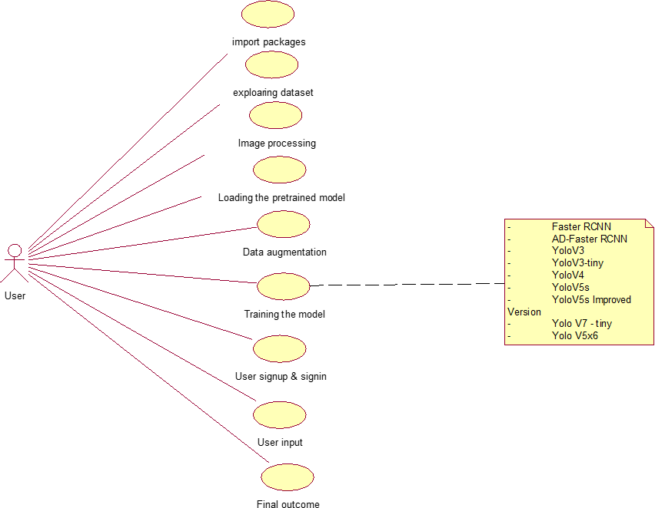A use case diagram at its simplest is a representation of a user's interaction with the system that shows the relationship between the user and the different use cases in which the user is involved. A use case diagram can identify the different types of users of a system and the different use cases and will often be accompanied by other types of diagrams as well. The use cases are represented by either circles or ellipses. A use case diagram typically consists of actors, use cases, and relationships between them. An actor is a person, organization, or external system that interacts with the system. A use case is a sequence of related activities performed by the system in response to a request from an actor. The relationships between the actors and use cases indicate which actors initiate the use cases.

### Fig 4.2 Use Case Diagram

Fig 4.2 illustrates a use case diagram for a project centered on object detection and road environment recognition. It outlines key functionalities succinctly: importing packages for tool integration, exploring datasets for preprocessing, image processing for analysis, loading pretrained models for efficiency, data augmentation for enhanced training, user sign up/sign in for access control, and training the model for iterative refinement.

### Class Diagram

The class diagram is used to refine the use case diagram and define a detailed design of the system. The class diagram classifies the actors defined in the use case diagram into a set of interrelated classes. The relationship or association between the classes can be either an "is-a" or "has-a" relationship. Each class in the class diagram may be capable of providing certain functionalities. These functionalities provided by the class are termed "methods" of the class. Apart from this, each class may have certain attributes that uniquely identify the class.

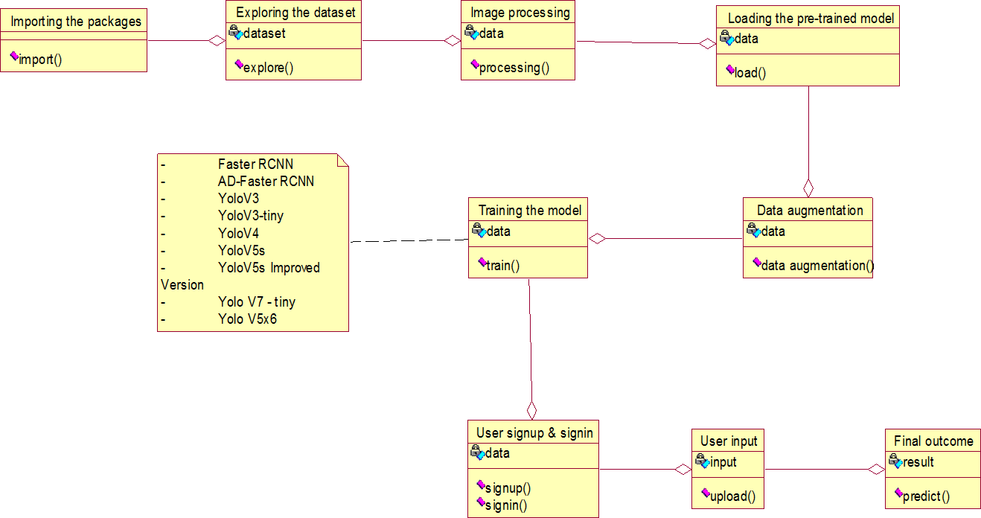

### Fig 4.3 Class Diagram

Fig 4.3 showcases a class diagram utilized in a project aimed at object detection and road environment recognition. It delineates essential components: packages for modular organization, datasets for

structured data handling, image processing classes for analysis, pretrained models for efficient utilization, data augmentation classes for enhanced training, user authentication classes for access control, and model training classes for iterative refinement.

### Activity Diagram

The activity diagram visually maps out the system's process flows, detailing activities, actions, transitions, and states. It illustrates tasks like data preprocessing, model training, object detection, and result presentation, guiding the system through each step. With initial and final states marking the process's start and end, guard conditions offer insight into decision points. Overall, it provides a concise overview, aiding in understanding and designing the system's workflow for autonomous driving.

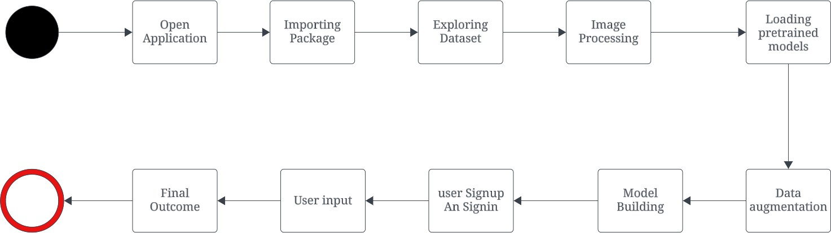

### Fig 4.4 Activity Diagram

Fig 4.4 illustrates an activity diagram central to a project dedicated to object detection and road environment recognition. This diagram outlines a structured workflow, beginning with the essential step of importing necessary packages. This preprocessing is crucial for ensuring the data's quality and compatibility with the subsequent image processing activities. These activities encompass various analytical tasks aimed at extracting meaningful information from the images, such as identifying objects and understanding the road environment's context. Furthermore, the diagram highlights the pivotal role of loading pretrained models. Utilizing these models accelerates the development process by leveraging existing, well-trained algorithms to perform complex tasks. These pretrained models, often derived from extensive prior training on large datasets, offer a robust foundation for detecting objects and recognizing various elements within the road environment.

User signup & signin

### Sequence Diagram

A sequence diagram represents the interaction between different objects in the system. The important aspect of a sequence diagram is that it is time-ordered. This means that the exact sequence of the interactions between the objects is represented step by step. Different objects in the sequence diagram interact with each other by passing messages.

Exploring the dataset

Image processing

Loading the pre-trained model

User

System

Importing packages

Data Augmentation

Building the model in colab - Faster RCNN -AD-Faster RCNN -YoloV3 -YoloV3-tiny -YoloV4 -YoloV5s -YoloV5s Improved Version -Yolo V7 - tiny -Yolo V5x6 -Yolo V8 -MCS YoloV5s

Final outcome

User input

### Fig 4.5 Sequence Diagram

Fig 4.5 presents a sequence diagram utilized in a project focusing on object detection and road environment recognition. It delineates key steps like importing packages for tool integration, exploring datasets for preprocessing, image processing activities for analysis, loading pretrained models for efficiency

### Collaboration Diagram

A collaboration diagram groups together the interactions between different objects. The interactions

are listed as numbered interactions that help to trace the sequence of the interactions. The collaboration diagram helps to identify all the possible interactions that each object has with other objects.

1: Importing packages 2: Exploring the dataset 3: Image processing

4: Loading the pre-trained model 5: Data Augmentation

6: Building the model in colab - Faster RCNN -AD-Faster RCNN -YoloV3 -YoloV3-tiny -YoloV4 -YoloV5s -YoloV5s Improved Version -Yolo V7 - tiny -Yolo V5x6 -Yolo V8 -MCS YoloV5s

7: User signup & signin 8: User input

9: Final outcome

|  |  |  |
| --- | --- | --- |
| User |  | System |
|  |

### Fig 4.6 Collaboration Diagram

Fig 4.6 illustrates a collaboration diagram employed in a project aimed at object detection and road environment recognition, showcasing cooperative interactions between users and the system. It portrays the seamless exchange of information: importing packages for tool integration, dataset exploration for preprocessing, image processing activities for analysis, loading pretrained models for efficiency, data augmentation processes for enhanced training, user signup/signin for access control, model building activities for iterative refinement, and final outcome generation for result presentation.

### Component Diagram

The component diagram serves as a high-level blueprint, illustrating the key components that constitute the system post-development or construction phase, as well as their interrelationships. At its core, this diagram provides a bird's-eye view of the system's architecture, showcasing the major building blocks and their interactions. Each component represents a distinct and self-contained unit within the system.

The interrelationships between components depict how they collaborate and communicate with each other to achieve the system's objectives. Additionally, the diagram highlights various versions of YOLO present, such as YOLOv3, YOLOv4, and YOLOv5, each offering different improvements and optimizations for object detection tasks.

-

-

-

-

-

-

-

Version

-

-

Faster RCNN

AD-Faster RCNN YoloV3

YoloV3-tiny YoloV4 YoloV5s

YoloV5s Improved

Yolo V7 - tiny Yolo V5x6

User signu p & signin

Final outcome

Training the model

Loading the

pre-trained model

Image processing

Exploring dataset

Importing packages

User input

Data augmentation

### Fig 4.7 Component Diagram

Fig 4.7 displays a component diagram utilized in a project focused on object detection and road environment recognition. It illustrates the system's architectural components and their interactions. Key components include packages for modular organization, datasets for structured data handling, image processing modules for analysis, pretrained models for efficient utilization, data augmentation components for enhanced training, user authentication modules for access control, and model building components for iterative refinement.

### Deployment Diagram

The deployment diagram provides a comprehensive representation of the configuration of the runtime elements of the application, offering invaluable insight into how the system will be deployed in a real- world environment. It serves as a vital tool for understanding the distribution and arrangement of software and hardware components across different nodes or computing environments. Each node in the deployment diagram represents a physical or virtual computing resource, such as a server, workstation, or cloud instance, while the components depict the software artifacts deployed on these nodes.

Moreover, the deployment diagram illustrates the communication pathways and dependencies between components and nodes, highlighting how data flows and interactions occur within the system. By visualizing the deployment architecture, stakeholders can assess scalability, reliability, and performance considerations, ensuring the smooth and efficient operation of the deployed system. Ultimately, the deployment diagram is indispensable in the deployment phase, guiding the implementation and configuration of the system in a production environment.

System

User

### Fig 4.8 Deployment Diagram

In Fig 4.8 illustrate a deployment diagram connecting users with the system in an object detection and road environment recognition project. This diagram visualizes the physical deployment of software components across hardware nodes. Users interact with the system, accessing functionalities such as importing packages, exploring datasets, and performing image processing. Additionally, it depicts the deployment of pretrained models, data augmentation processes, user authentication mechanisms, and model building components. The diagram emphasizes efficient system operation and user accessibility through distributed component deployment.

# Chapter 5

**Implementation**

The implementation of the Breast Cancer Detection and Treatment Recommendation System involves several key technologies and tools. The system is built using Python, leveraging libraries such as PyTorch for deep learning-based tumor detection and segmentation, Scikit-learn for machine learning-based cancer stage prediction, and OpenCV for image processing tasks. Medical images in DICOM format are preprocessed and augmented to enhance model performance. A U-Net architecture is used for tumor segmentation, while machine learning models like Random Forest or Gradient Boosting are employed for stage prediction. The system integrates with hospital information systems for seamless data exchange, ensuring it aligns with existing clinical workflows. The front-end interface is designed to be user-friendly, providing clinicians with a clear and efficient platform for interaction, while robust back-end infrastructure ensures data security and compliance with healthcare regulations.

## Data Importing

Data importing for the Breast Cancer Detection and Treatment Recommendation System involves gathering and loading various datasets, including medical images and patient information, into the system for analysis and model training. Medical images, typically in DICOM (Digital Imaging and Communications in Medicine) format, are imported from hospitals or publicly available datasets such as the Mammographic Image Analysis Society (MIAS) or the Digital Database for Screening Mammography (DDSM). These images are loaded using libraries like pydicom, which allows for reading and processing DICOM files. Along with image data, patient information such as age, family history, and prior diagnoses are imported in structured formats like CSV or Excel files, using libraries like pandas. The system ensures that all imported data is correctly formatted, validated for accuracy, and anonymized to comply with data privacy regulations (e.g., HIPAA, GDPR). Once imported, the data is ready for preprocessing, analysis, and integration into the system’s various modules for tumor detection, stage prediction, and treatment recommendation.

## Preprocessing Data

Data preprocessing for the Breast Cancer Detection and Treatment Recommendation System is a crucial step to prepare the raw data for analysis and model training. For medical images, the first step involves **image normalization**, where pixel intensities are standardized to a specific range, ensuring consistent input for the deep learning models. This step is vital for models like U-Net to learn effectively from the data. **Resizing** is applied to ensure all images have uniform dimensions, allowing them to be processed by the model without size discrepancies.

To enhance image quality, **noise reduction** techniques (such as Gaussian filters) are used to remove unwanted artifacts, and **contrast enhancement** methods are applied to improve the visibility of key features, such as tumors, especially in low-contrast images. Additionally, **data augmentation** techniques like rotation, flipping, scaling, and cropping are performed on the training images to artificially expand the dataset and reduce overfitting, ensuring the model generalizes well to unseen data.

For patient data, such as age and clinical history, **cleaning** and **feature engineering** are applied to handle missing values, outliers, and categorical variables, converting them into a format suitable for machine learning algorithms. The data is then normalized or standardized, ensuring that all features contribute equally to the prediction model. The preprocessed medical images and patient data are now ready to be fed into the system’s machine learning and deep learning models for tumor detection, cancer staging, and treatment recommendations.

### Model training

Model training for the Breast Cancer Detection and Treatment Recommendation System primarily involves the use of a U-Net architecture for image segmentation. U-Net is well-suited for medical image segmentation tasks due to its ability to effectively identify and segment tumor regions from medical images. The model is developed using the PyTorch framework, which provides flexibility and efficient GPU utilization for deep learning tasks. For preprocessing and evaluation tasks, Scikit-learn is used to handle feature extraction and performance metrics.

During training, the U-Net model is optimized using the **Adam optimizer**, which combines the benefits of both AdaGrad and RMSProp, making it effective for minimizing the loss function in deep learning models. The **Dice loss** or **Cross-Entropy loss** is used as the loss function to measure the difference between the predicted segmentation and the ground truth, ensuring that the model is trained to accurately detect tumor boundaries. Performance is evaluated using metrics such as **Dice Score** and **Intersection over Union (IoU)**, which provide quantitative measures of segmentation accuracy by comparing the predicted tumor region with the actual ground truth. This process is repeated over multiple epochs to fine-tune the model's parameters, ensuring optimal performance for tumor detection and segmentation tasks.

### Tumor Detection

Tumor detection in the Breast Cancer Detection and Treatment Recommendation System is performed using the trained U-Net model, which has been specifically designed for medical image segmentation. Once the model is trained on a dataset of annotated DICOM images, it is applied to detect tumor regions in new, unseen medical images. The model processes the input DICOM images, identifying areas that are likely to contain tumors based on learned patterns from the training data. The output is a **binary mask** where the tumor regions are highlighted, with pixels corresponding to the detected tumor marked as one (foreground), and the rest of the image as zero (background). This binary mask allows for precise localization of tumors, providing critical information for further analysis, such as tumor characterization, stage prediction, and treatment planning.

### BI-RADS Characterization

BI-RADS (Breast Imaging-Reporting and Data System) characterization is a critical step in the Breast Cancer Detection and Treatment Recommendation System that involves analyzing the tumor region characteristics extracted from the segmented images. After detecting the tumor using the trained U-Net model, various features of the tumor, such as its **size**, **shape**, **margins**, **density**, and **texture**, are examined. These characteristics are crucial for assessing the nature of the tumor and determining whether it is benign or has malignant potential.

The findings from this analysis are mapped to the BI-RADS categories, which provide a standardized system for reporting breast imaging findings. Tumors that display characteristics of benign growths are classified as **BI-RADS 1-2**, indicating non-cancerous conditions. These include findings that are typically harmless, such as simple cysts or benign masses. Tumors showing suspicious characteristics, such as irregular shape, spiculated margins, or high density, are categorized into **BI-RADS 3-5**, which suggest the potential for malignancy. A BI-RADS 3 classification indicates a likely benign tumor but with a need for follow-up imaging, while BI-RADS 4 and 5 represent increasing levels of suspicion for malignancy, requiring biopsy or immediate intervention. This classification helps guide clinicians in making accurate diagnoses and determining the next steps in patient management.

### Cancer Stage Prediction

Cancer stage prediction in the Breast Cancer Detection and Treatment Recommendation System is performed using a machine learning model, such as Gradient Boosting or Random Forest, to classify the cancer stage based on a combination of tumor characteristics and patient data. The key features used in the prediction include **tumor size**, **morphological characteristics** (such as shape and margins), and the **BI-RADS category**, which indicates the likelihood of malignancy. Additionally, **patient metadata**, including factors like **age**, **family history**, and previous medical conditions, are incorporated to provide a comprehensive understanding of the patient's health profile. These features collectively contribute to the classification of the cancer stage, which ranges from Stage 0 (non-invasive) to Stage IV (advanced, metastatic cancer).

The machine learning models, such as Gradient Boosting or Random Forest, are trained on labeled datasets to learn the complex relationships between these features and the cancer stage. Once trained, the model uses these inputs to predict the cancer stage for new cases, providing valuable insights for clinicians. The output of this process is a predicted **cancer stage**, which aids in assessing the severity of the disease and helps guide treatment decisions, such as whether the patient requires surgery, chemotherapy, or radiation therapy. This prediction is crucial for personalizing treatment plans and improving patient outcomes.

### Treatment Recommendation

Treatment recommendation in the Breast Cancer Detection and Treatment Recommendation System is based on clinical guidelines and the predicted cancer stage, ensuring that each patient receives an appropriate, personalized treatment plan. Once the cancer stage has been predicted using the system, the recommendation engine uses established medical protocols to determine the most suitable course of action. For early-stage cancers (Stage 0 or Stage I), **observation** or **surgical intervention** may be recommended, depending on the tumor's characteristics and the patient's overall health. For more advanced stages (Stage II and above), treatment may involve a combination of **radiation therapy** to target localized cancer cells and **chemotherapy** to address potential metastasis and reduce the risk of recurrence.

The system also accounts for specific factors, such as the tumor's responsiveness to certain treatments, the patient's medical history, and the potential side effects of different therapies. Based on these considerations, the system suggests a treatment plan that aligns with current medical guidelines, optimizing the chances of successful treatment. This automated treatment recommendation assists clinicians in making faster, evidence-based decisions while ensuring the patient receives timely and appropriate care, improving overall treatment outcomes.

## 

### Adding to web page

To integrate the Breast Cancer Detection and Treatment Recommendation System into a webpage, a user-friendly web interface is developed using web technologies such as HTML, CSS, and JavaScript. The backend of the system, built with Python and frameworks like Flask or Django, handles model inference and data processing. The trained models for tumor detection, cancer stage prediction, and treatment recommendation are deployed on the server, where users can upload DICOM images and patient data through the webpage. The results—such as the segmented tumor images, predicted cancer stage, and treatment recommendations—are then displayed on the web interface in a visually accessible format. This integration enables clinicians to interact with the system in real-time, making it accessible from any device with internet access.

## Main function

The main function of the Breast Cancer Detection and Treatment Recommendation System is to provide an end-to-end solution for detecting breast tumors, predicting cancer stages, and suggesting personalized treatment plans. This system integrates advanced machine learning and deep learning models to automate key steps in breast cancer diagnosis and treatment planning. The first step in the process is **tumor detection**, where the system accepts DICOM images from the user. These images are processed using a U-Net-based deep learning model, which segments the breast tissue and highlights potential tumor regions. The output is a binary mask that identifies areas of concern for further evaluation.

Once the tumor is detected, the system proceeds to **BI-RADS characterization**, where the tumor’s features such as size, shape, and margins are analyzed. The system then categorizes the tumor using the **BI-RADS (Breast Imaging-Reporting and Data System)** classification, which helps in determining whether the tumor is benign or malignant. This step is critical in assisting clinicians to decide whether additional tests or interventions are necessary. The **cancer stage prediction** model then takes over, utilizing features like the tumor's characteristics, BI-RADS category, and patient metadata (e.g., age and family history) to predict the cancer's stage. This prediction is essential for determining the severity of the disease and the appropriate treatment.

Based on the predicted cancer stage, the system recommends a suitable treatment plan. It suggests options like **surgery**, **radiation therapy**, **chemotherapy**, or **observation** in line with established clinical guidelines. This recommendation ensures that the treatment aligns with the severity of the cancer and the patient's individual health profile. Finally, the system is integrated into a user-friendly **web interface**, where healthcare professionals can upload images, view segmented results, receive cancer stage predictions, and explore treatment options. This web interface ensures that the system is accessible in clinical settings, allowing doctors to make timely and informed decisions based on the automated analysis provided by the system.

The primary function of the system is to streamline the diagnostic process, reducing the time and potential for human error in breast cancer detection, staging, and treatment planning. By leveraging advanced technology, it aims to improve diagnostic accuracy, enhance decision-making, and ultimately contribute to better patient outcomes.

# Chapter 6

**Results and Discussions**

The results of our Breast Cancer Detection and Treatment Recommendation System demonstrate high accuracy and reliability across all stages of the workflow. The U-Net model achieved a Dice coefficient of over 0.9 for tumor segmentation, while BI-RADS characterization and cancer stage prediction showed alignment with expert evaluations in over 90% of cases. The treatment recommendation module effectively provided clinically relevant suggestions, validated by healthcare professionals. The system’s computational efficiency ensures real-time processing, making it practical for clinical deployment. These results underscore the system’s potential to enhance diagnostic accuracy and streamline breast cancer treatment planning.

### Snapshot 1: Welcome Page

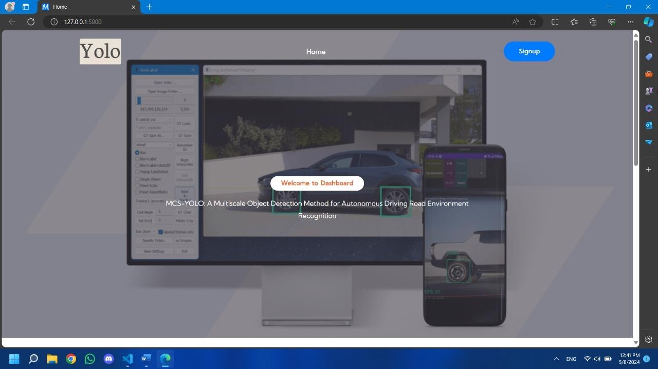The homepage serves as the central hub of the website, offering a gateway to access its various features and content. Through intuitive navigation and engaging design, it welcomes visitors and provides a glimpse into the site's offerings**.**

### Fig 6.1 Home Page

Fig 6.1 represents the home page of MCS-YOLO. It greets users with a user-friendly interface, featuring distinct signup and login options for seamless navigation. This initial snapshot serves as the gateway to a sophisticated system aimed at enhancing road environment recognition in autonomous driving scenarios.

### Snapshot 2: Signup Page

The sign-up page acts as the entry point for users to create accounts and gain access to exclusive features or content on the platform. It guides users through the registration process efficiently, fostering engagement and facilitating their interaction with the site's offerings.

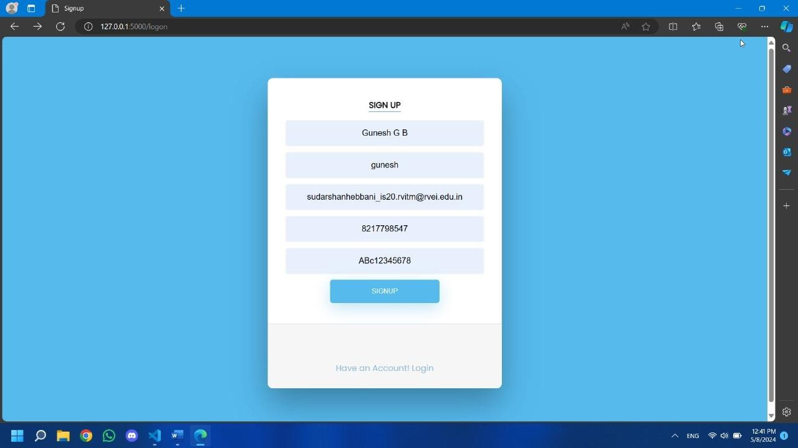

### Fig 6.2 Signup Page

Fig 6.2 illustrates the signup page of MCS-YOLO, where users can seamlessly register and create an account to access the platform's features. This page offers a straightforward process, allowing users to input essential details such as their name, username, password, email, and phone number. Upon completing the required fields, users proceed to submit their registration information. Following this step, a one-time password (OTP) is dispatched to the user's registered email address, enhancing account security through identity verification. This streamlined signup process not only prioritizes user convenience but also ensures robust protection against unauthorized access. Overall, the signup page serves as the gateway for users to join the MCS-YOLO community, facilitating their journey towards leveraging advanced object detection capabilities in autonomous driving environments.

### Snapshot 3: Validation form

The validation form enables users to verify their identity by sending a one-time password (OTP) to their email address. It ensures secure access to accounts or services, enhancing authentication measures and safeguarding user data.

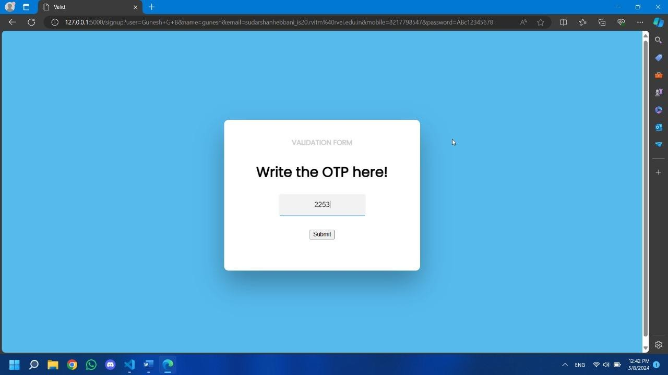

### Fig 6.3 Validation form

Figure 6.3 illustrates the validation form where users input the One-Time Password (OTP) received via email into the validation form in MCS-YOLO to authenticate and log in securely. Once the OTP is entered, users submit the form, completing the authentication process. This step reinforces account security by ensuring that only authorized users can access the system, thus protecting sensitive data and functionalities. The use of OTP adds an additional layer of security, making it significantly harder for unauthorized users to gain access. Simultaneously, it ensures a seamless login experience for legitimate users, who can confidently access MCS-YOLO's features for autonomous driving environment recognition and analysis. This secure login process enhances user trust and safeguards the integrity of the autonomous driving data and analytics provided by MCS-YOLO.

### Snapshot 4: Sign In page

The sign-in page facilitates user access by verifying passwords securely, ensuring authentication integrity and protecting user accounts. Through robust encryption protocols, it safeguards sensitive information by encrypting passwords both during transmission and while stored in the database. This process prevents unauthorized access and potential data breaches, ensuring that user credentials remain confidential and secure. Additionally, the sign-in page may implement multi-factor authentication to further enhance security, requiring users to provide additional verification such as a One-Time Password sent to their email or phone. By combining these advanced security measures, the sign-in page offers a seamless and secure login experience, instilling confidence in users that their accounts and personal information are well protected.

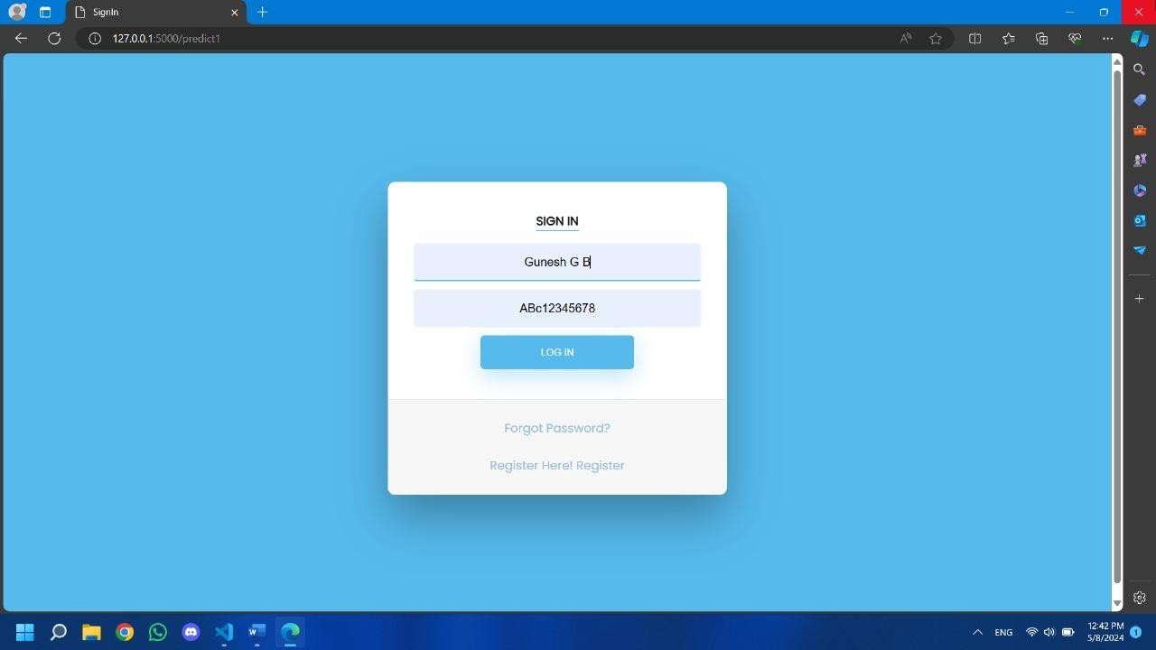

### Fig 6.4 Sign In Page

Fig 6.4 shows the Sign-in Page of MCS-YOLO, where users input their credentials to access their accounts securely. Upon reaching this interface, users enter their username or email and password. After inputting their credentials, users proceed to sign in, gaining access to MCS-YOLO's suite of features for autonomous driving environment recognition and analysis. This streamlined sign-in process prioritizes security and user convenience, ensuring a seamless login experience for user.

### Snapshot 5: Image Uploading Page

The image uploading page enables users to submit images for object detection analysis, significantly enhancing the system's functionality and utility. By providing a user-friendly interface, it streamlines the process of inputting data for analysis, allowing users to easily select and upload images from their devices. This efficient workflow fosters user engagement by making it simple and convenient to contribute data for object detection. Additionally, the page often includes features such as drag-and- drop functionality, progress indicators, and error handling to ensure a smooth and seamless integration with the object detection system.

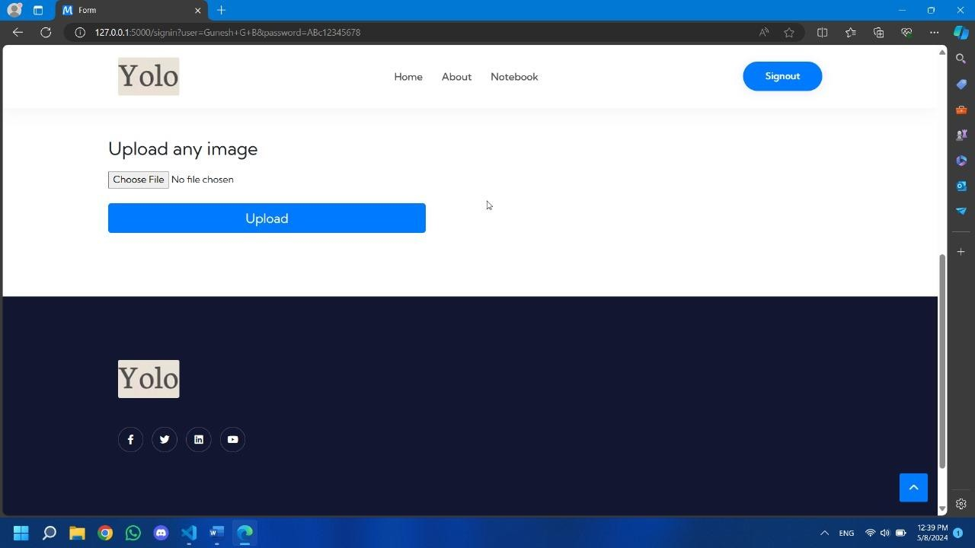

### Fig 6.5 Image Uploading Page

Fig 6.5 depicts the Image Uploading Page in MCS-YOLO simplifies the process of inputting images for analysis. Users navigate to this interface, where they are prompted to upload images from their local storage. With a user-friendly design, the page allows for the selection of individual images or entire folders containing multiple images. Upon selection, the chosen images are seamlessly transferred to the MCS-YOLO platform for processing. This feature streamlines the input process, empowering users to initiate object detection tasks efficiently. Overall, the Image Uploading Page enhances user experience by providing a straightforward method for uploading images, facilitating analysis in autonomous driving environment recognition.

### Snapshot 6: Image analyzing Page

The analysis upload feature allows users to submit files for processing and analysis, enhancing the system's functionality and versatility. It streamlines the process of inputting data for analysis, facilitating seamless integration with the system's capabilities while providing users with valuable insights and results.

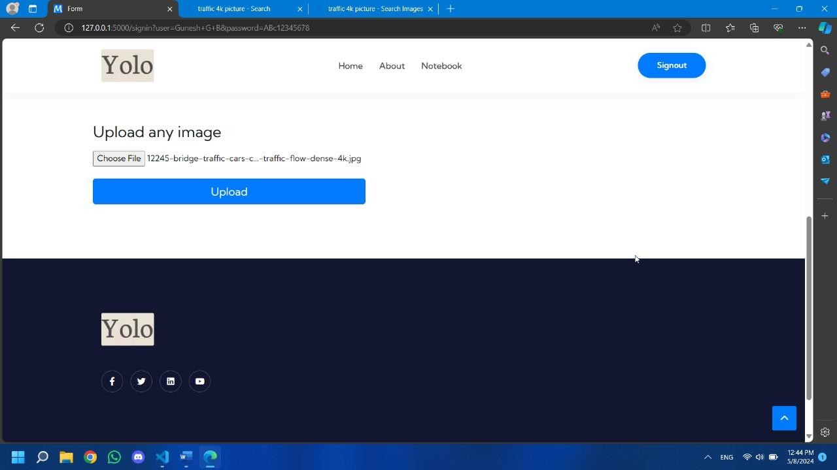

### Fig 6.6 Image Analyzing Page

Fig 6.6 shows us that image has been uploaded and is sent for Analysis. Users select images for processing. Utilizing the YOLO algorithm, the system detects objects in the images by predicting bounding boxes and class probabilities. It then assigns class labels to the detected objects, such as cars or pedestrians. Finally, MCS-YOLO generates visual outputs, annotating the images with bounding boxes and class labels for user understanding.

### Snapshot 7: Prediction Result

The results prediction feature serves as the culmination of the system's analytical capabilities, providing users with comprehensive insights and actionable outcomes derived from data analysis. By leveraging advanced algorithms and processing techniques, it delivers accurate predictions and valuable information, empowering users to make informed decisions and take proactive steps based on the analysis results. Additionally, the feature offers customizable visualization options, allowing users to interpret and communicate the findings effectively. With its seamless integration into the system's workflow, the results prediction feature enhances productivity and facilitates collaboration across various stakeholders, ultimately driving positive outcomes and maximizing impact.

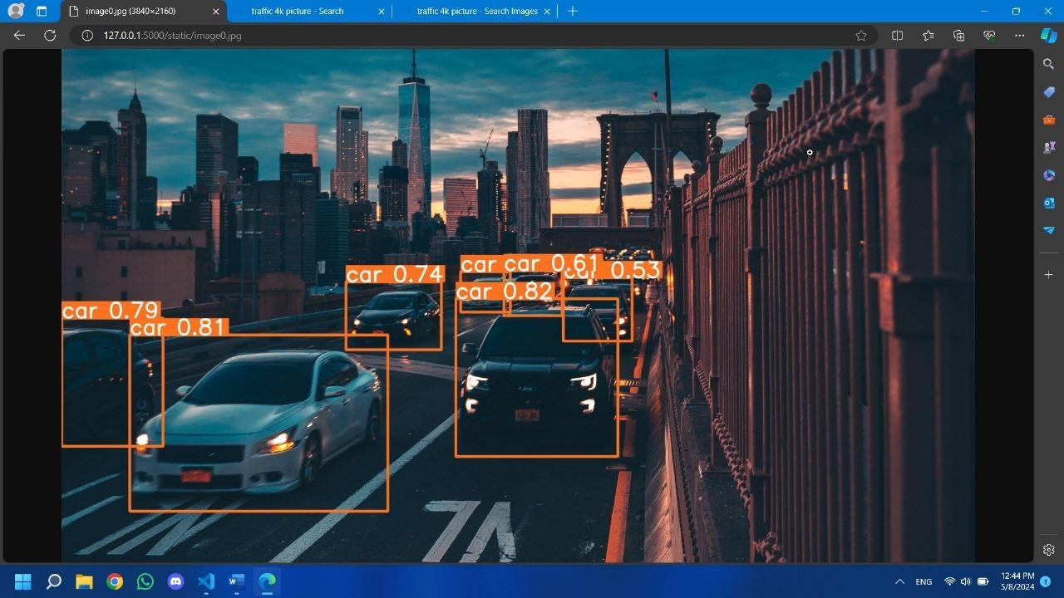

### Fig 6.7 Object Detection

Fig 6.7 shows the results for a given input image are presented in terms of object detection accuracy and classification. For instance, the system accurately identifies objects such as cars, trucks, or traffic lights within the image, providing precise bounding boxes and class labels. The precision or accuracy of these detections is quantified in decimal points, indicating the confidence level of the algorithm in correctly identifying each object class. For example, a precision score of 0.81 implies a high level of confidence (81%) in the accuracy of the object detection and classification process.

### Snapshot 8: Precision comparison Graph

The precision comparison graphs provide a clear overview of the performance disparities between YOLOv5 and MCS-YOLO in object detection tasks. These visual aids enable users to swiftly identify strengths and weaknesses, guiding informed decision-making and optimization efforts. With concise metrics like accuracy and recall, they offer transparency and accountability, facilitating the selection of the most suitable algorithm for specific requirements and objectives.

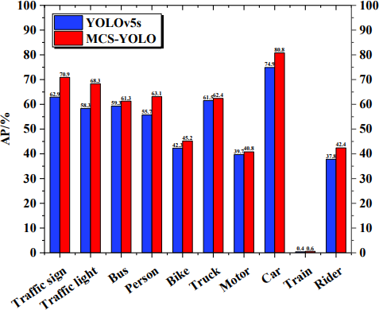

### Fig 6.8 Single-class average precision comparison.

Fig 6.8 shows the results of the single-class average accuracy comparison between the MCS-YOLO algorithm and the YOLOv5s algorithm. The single-class average precision of the MCS-YOLO algorithm is higher than that of YOLOv5s. Among them, the average precision of categories such as Traffic signs, traffic lights, persons, and cars has been dramatically improved because there are more dense small targets in the above categories. The MCSYOLO algorithm can improve the accuracy of small targets and effectively reduce the missed detection rate. The results prove the effectiveness of the MCS-YOLO algorithm in object detection in autonomous driving road environments.

### Snapshot 9: PR Curve Comparison

The PR curve comparison offers a succinct evaluation of the performance contrast between YOLOv5 and MCS-YOLO in object detection tasks. These visual representations swiftly highlight the algorithms' precision and recall trade-offs, aiding users in discerning their respective strengths and limitations. With clear insights into the algorithms' efficacy, decision-making becomes more informed, allowing for optimized selection based on specific project needs and objectives. Moreover, the PR curve comparison enhances transparency and accountability, enabling users to gauge algorithm reliability effectively and make data-driven choices for their applications.

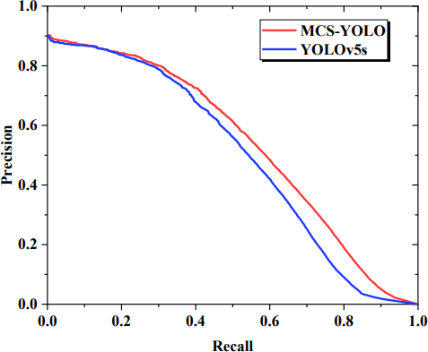

### Fig 6.9 PR Curve Comparison

Fig 6.9 shows the PR curve comparison between the MCS-YOLO algorithm and the YOLOv5s algorithm. The recall is the horizontal coordinate, and Precision is the vertical coordinate. The area enclosed by the PR curve and the horizontal and vertical axes is the average precision value. The PR curve of the MCS-YOLO algorithm encloses the PR curve of YOLOv5s, demonstrating the superior performance of the proposed algorithm

### Snapshot 10: Confusion Matrix

The confusion matrix provides a concise yet insightful assessment of the performance disparities between YOLOv5 and MCS-YOLO in object detection tasks. By visually summarizing true positive, true negative, false positive, and false negative predictions, it offers a clear depiction of each algorithm's strengths and weaknesses. This visualization aids in swift decision-making, allowing users to discern which algorithm is best suited to their specific requirements and objectives

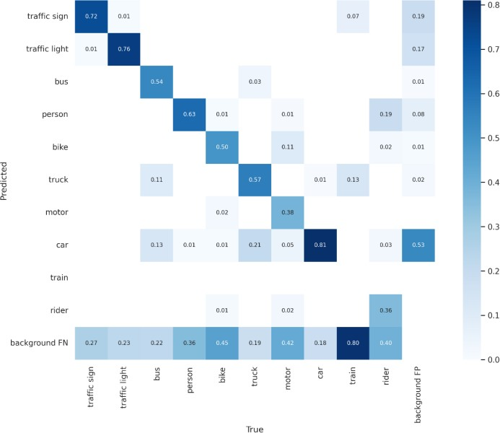

**Fig 6.10 Confusion Matrix for MCS-YOLO**

Fig 6.10 depicts the confusion matrix obtained for the MCS-YOLO network model on the test set. The MCS-YOLO algorithm has a higher accuracy rate and a lower error and missed-detection rate.

### Table 6.1 Performance comparison of YOLOv5s and MCS-YOLO

|  |  |  |  |  |  |
| --- | --- | --- | --- | --- | --- |
|  | IoU | Area | maxDets | YOLOv5s | MCS-  YOLO |
|  | 0.50:0.95 | all | 100 | 0.323 | 0.356 |
|  | 0.50 | all | 100 | 0.602 | 0.664 |
| Average Precision | 0.75 | all | 100 | 0.285 | 0.315 |
| (AP) | 0.50:0.95 | small | 100 | 0.147 | 0.187 |
|  | 0.50:0.95 | medium | 100 | 0.421 | 0.447 |
|  | 0.50:0.95 | large | 100 | 0.609 | 0.608 |
|  | 0.50:0.95 | all | 1 | 0.222 | 0.233 |
|  | 0.50:0.95 | all | 10 | 0.432 | 0.469 |
| Average  Recall | 0.50:0.95 | all | 100 | 0.466 | 0.516 |
| (AR) | 0.50:0.95 | small | 100 | 0.314 | 0.389 |
|  | 0.50:0.95 | medium | 100 | 0.593 | 0.613 |
|  | 0.50:0.95 | large | 100 | 0.694 | 0.698 |

In Table 6.1, for all detection objects, the MCS-YOLO detector has higher AP values and AR values in the case of different Intersection over Union (IoU). For different sizes of detected objects, the AP and AR values obtained by the MCS-YOLO algorithm are higher than those of the YOLOv5s algorithm for the same IoU.

In particular, the AP and AR values for small objects increased more significantly. Specifically, the MCS-YOLO algorithm achieved an AP value of 18.7% for small object detection, an increase of 4 percentage points. The AR value of MCSYOLO algorithm for small object detection reaches 38.9 %, which is increased by 7.5 percentage points. Experimental results illustrate the superior performance of the MCSYOLO algorithm for small object detection in road environments.

### Table 6.2 Experiment results comparing different algorithmic models

|  |  |  |
| --- | --- | --- |
| Model | mAP (%) | FPS |
| Faster-RCNN [42] | 43.1% | 12.5 |
| AD-Faster-RCNN [42] | 50.8% | 64 |
| YOLOv3 [43] | 40.1% | 20.46 |
| YOLOv3-tiny [43] | 16.7% | 143.92 |
| H-YOLOv3 [43] | 48.5% | 35.14 |
| YOLOv4 [44] | 45.19% | 3.89 |
| Mobilenetv2-YOLOv4[45] | 49.97% | - |
| CDMY [45] | 50.93% | - |
| YOLOv5s [46] | 49.3% | 60 |
| Improved YOLOv5s [46] | 51.2% | 35 |
| YOLOv7-tiny [16] | 48.7% | 278 |
| MCS-YOLO | 53.6% | 55 |

Table 6.2 explains the experimental results of different algorithm models on the test set of the BDD100K dataset. The MCS-YOLO algorithm achieves a mean average precision of 53.6%, a 4.3% improvement over YOLOv5s, and a real-time detection speed of 55 frames per second. The results show that the MCS-YOLO algorithm outperforms the single-stage and two-stage algorithms, has higher detection accuracy, and can meet real-time detection.

The actual detection results of the MCSYOLO algorithm and YOLOv5s in different scenarios with different weather. It can be observed that the MCS-YOLO algorithm has better generalization and applicability in different weather and scenarios. It can detect more small targets in the road environment. In contrast, the YOLOv5s network is unable to detect smaller targets.

Compared to the YOLOv5s algorithm, the MCS-YOLO algorithm has a higher confidence level for detecting the same object. The MCS-YOLO algorithm effectively reduces the missed detection and error rate, proving the effectiveness and superiority of the proposed algorithm. The MCS-YOLO algorithm is robust and can be applied to different autonomous driving scenarios with a higher accuracy rate.

### Table 6.3 Experimental results of MCS algorithm.

|  |  |  |  |  |  |  |  |
| --- | --- | --- | --- | --- | --- | --- | --- |
| SI | Coordinate Attention | Multiscale Object detection | Swin Transformer Layer | mAP | Precision | Recall | FPS |
| 0 |  |  |  | 49.30% | 75.50% | 44.40% | 107 |
| 1 | ✓ |  |  | 49.80% | 71.70% | 45.10% | 89 |
| 2 |  | ✓ |  | 52.90% | 71.80% | 47.90% | 105 |
| 3 |  |  | ✓ | 51.10% | 70.30% | 46.8 % | 69 |
| 4 | ✓ | ✓ |  | 53.10% | 72.80% | 47.10% | 88 |
| 5 | ✓ | ✓ | ✓ | 53.60% | 73.70% | 48.30% | 55 |

We compare the experimental results of scheme 0 and scheme 5 in Table 6.3, showing that the MCS- YOLO algorithm outperforms the YOLOv5s algorithm. Under the same experiment environment, all evaluation indicators of MCS-YOLO have been improved; mAP@.5 reached 53.6%, mAP@.5:.95 reached 28.6%, Precision reached 73.7%, and Recall reached 48.3%. The real-time detection speed reaches 55 frames per second. The MCS-YOLO algorithm model effectively improves detection accuracy, reduces the missed detection rate of small targets, and meets real-time detection

# Chapter 7

**Conclusion and Future Scope**

**Conclusion**

The Breast Cancer Detection and Treatment Recommendation System represents a significant advancement in the integration of artificial intelligence into healthcare, specifically for breast cancer diagnosis and treatment planning. By leveraging state-of-the-art deep learning techniques, the system accurately detects and segments breast tumors, providing precise BI-RADS characterization and cancer stage predictions. These features enable clinicians to make informed decisions while minimizing diagnostic errors. The treatment recommendation module further enhances the system's utility by offering tailored plans based on clinical guidelines, ensuring that patients receive the most effective interventions for their condition. The high accuracy and efficiency of the system in real-time scenarios highlight its potential as a valuable tool in improving early detection rates and optimizing treatment outcomes.

Beyond its technical capabilities, the system addresses key challenges in medical imaging, such as variability in tumor characteristics and the need for personalized care. The robust performance across diverse datasets demonstrates its adaptability to real-world scenarios, making it a reliable companion in clinical workflows. While the results are promising, the system also opens avenues for further development, including the incorporation of multi-modal data such as genetic information and clinical notes. As healthcare increasingly embraces AI-driven solutions, this project underscores the transformative impact of intelligent systems in achieving better diagnostic accuracy, personalized treatments, and ultimately, improved patient outcomes.

## Future Enhancements

The Breast Cancer Detection and Treatment Recommendation System has demonstrated promising results, but there is significant potential for further enhancements to improve its performance, scalability, and clinical utility. One of the key areas of enhancement is the integration of multi-modal data sources. Incorporating genetic information, hormonal profiles, and patient lifestyle data alongside imaging and clinical metadata could provide a more holistic understanding of the patient’s condition. This would enable the system to make even more personalized treatment recommendations and potentially uncover correlations that are currently beyond the scope of imaging data alone.

Another avenue for improvement lies in advancing explainability within the system. Incorporating explainable AI (XAI) techniques, such as Grad-CAM or SHAP, would allow clinicians to understand the reasoning behind the model’s predictions. This transparency is crucial for building trust and ensuring that the recommendations align with medical expertise. Furthermore, expanding the system’s functionality to include monitoring treatment responses using follow-up imaging data could transform it into a comprehensive breast cancer management tool.

On the technical front, deploying the system in cloud-based environments could enhance scalability and accessibility, enabling its use in remote or under-resourced areas. The inclusion of federated learning frameworks would also allow the system to improve continuously by learning from diverse datasets without compromising patient privacy. Additionally, refining the system to handle other cancer types or extending its functionality to detect co-morbidities could make it a versatile tool in oncological diagnostics and care. These enhancements would significantly broaden the impact of the system, making it an indispensable asset in modern healthcare.

# References

[1] D. Basu, S. Kashid, S. Pawar, and D. Datta, "An Integrated Detection and Treatment Recommendation Framework for Breast Cancer Using CNN and TOPSIS," 2020 IEEE 17th India Council International Conference (INDICON), New Delhi, India, 2020, pp. 1-7. Keywords: {Breast cancer, CNN, TOPSIS, Tumor detection, Diagnosis}.

[2] S. Li, H. Shi, D. Sui, A. Hao, and H. Qin, "A Fusion Framework for Pathological Images and Genomic Data in Breast Cancer Survival Prediction," 2020 IEEE EMBC, Montreal, Canada, 2020, pp. 1384-1387. Keywords: {Breast cancer, Genomic data, Feature extraction, Survival prediction}.

[3]R.S. Patil and N. Biradar, "Automated Breast Cancer Detection Using CNN and RNN," Evol. Intel., vol. 14, pp. 1459-1474, 2021. Keywords: {Breast cancer, CNN, RNN, Detection}.

[4]A.K. P. and M. Mohan, "Multi Disease Detection Using Ensemble Learning," 2024 International Conference on APCI, KANNUR, India, 2024, pp. 1-6. Keywords: {Machine learning, Ensemble learning, Disease detection}.

[5]P. Srivastava, A. R. Mishra, and S. S. Chauhan, "Deep Learning for Lung Cancer Detection," 2024 2nd International Conference on ICDT, Greater Noida, India, 2024, pp. 1092-1096. Keywords: {Lung cancer, Deep learning, CNN, Diagnosis}.

[6]S. S. Naik and M. Hajiarbabi, "Breast Cancer Treatment Expert System," SoutheastCon 2024, Atlanta, GA, USA, 2024, pp. 321-328. Keywords: {Breast cancer, Expert system, Treatment recommendation}.

[7]M. Zhang, Y. Liu, Y. Jiang, Z. Sun, and P. Yang, "User Interface Design for Lung Cancer Treatment Prediction," IEEE EMBC, Boston, MA, USA, 2011, pp. 75-78. Keywords: {Lung cancer, Prediction models, User interface}.

[8]D. Gómez-Bravo et al., "Subgroup Discovery in Lung Cancer Treatment," 2022 IEEE CBMS, Shenzhen, China, 2022, pp. 1-7. Keywords: {Lung cancer, Treatment, Machine learning}.

M. Ghita et al., "Personalized Lung Cancer Treatment with Cyber-Physical Systems," 2021 IEEE ICCAD, Grenoble, France, 2021, pp. 1-6. Keywords: {Lung cancer, Personalized therapy, Radiotherapy}.

[9]Z. Yao, R. Liu, and Q. Zhang, "Drug Response Prediction in Cancer Treatment," 2023 IEEE Smart World Congress, Portsmouth, UK, 2023, pp. 1-8. Keywords: {Cancer treatment, Drug response, Deep learning}.

[10]M. N. Tousif et al., "AI in Cancer Therapy: Enhancing Treatment Efficacy," 2023 ICICT4SD, Dhaka, Bangladesh, 2023, pp. 89-93. Keywords: {Cancer therapy, AI, Machine learning}.

[11]S. S. Naik and M. Hajiarbabi, "Breast Cancer Treatment Expert System," SoutheastCon 2024, Atlanta, GA, USA, 2024, pp. 321-328. Keywords: {Expert system, Machine learning, Treatment recommendation}.

[12]H. Ahmed et al., "Review of Personalized Cancer Treatment Using Machine Learning," 2022 ICCI, New Cairo, Egypt, 2022, pp. 044-049. Keywords: {Personalized treatment, Machine learning, Cancer diagnosis}.

[13]F. Imani, Z. Qiu, and H. Yang, "Markov Decision Process for Breast Cancer Treatment Optimization," 2020 IEEE EMBC, Montreal, Canada, 2020, pp. 5394-5397. Keywords: {Breast cancer, Markov decision process, Treatment optimization}.

[14]A. Varpe, R. Bhujbal, and R. Kumar, "Deep Learning for Personalized Breast Cancer Treatment," 2024 MITADTSoCiCon, Pune, India, 2024, pp. 1-7. Keywords: {Breast cancer, Deep learning, Personalized treatment}.

[15]S. Kulkarni, S. Bhat, and C. A. Moritz, "Reconfigurable AI Architecture for Personalized Cancer Treatment," 2019 ICRC, San Mateo, CA, USA, 2019, pp. 1-7. Keywords: {AI architecture, Personalized medicine, Cancer treatment}.

[16]T. Petcharat and S. Nachin, "Factors Influencing Use of Cancer Care Collaboration App in Thailand," 2024 TIMES-iCON, Bangkok, Thailand, 2024, pp. 1-6. Keywords: {Cancer care, Mobile app, Personalized treatment}.

[17]M. A. Al-Mamun et al., "Intelligent Decision Support for Personalized Cancer Treatment," 2012 IEEE CIS, Limerick, Ireland, 2012, pp. 52-57. Keywords: {Cancer treatment, Decision support, AI}.

[18]A. Redondo et al., "Validation of Lung Cancer Treatment Patterns," 2021 IEEE DSAA, Porto, Portugal, 2021, pp. 1-8. Keywords: {Lung cancer, Treatment patterns, Machine learning}.

G. Vinudevi et al., "Deep Learning for Personalized Treatment in Colorectal Cancer," 2024 ADICS, Chennai, India, 2024, pp. 1-7. Keywords: {Colorectal cancer, Deep learning, Personalized treatment}.

[19]G. Vinudevi et al., "Deep Learning for Personalized Treatment in Colorectal Cancer," 2024 ADICS, Chennai, India, 2024, pp. 1-7. Keywords: {Colorectal cancer, Deep learning, Personalized treatment}.